A MODERN APPROACH TO CLOUD DATA
SECURITY WITH ELLIPTIC CURVE CRYPTOGRAPHY
A project report submitted in partial fulfillment for the award of the degree of

BACHELOR OF TECHNOLOGY IN
COMPUTER SCIENCE AND ENGINEERING (CYBERSECURITY)

by

THESETTY PHANI SHIVA RAM 22BFA37119 PENNALURUPETA VENU GOPAL 22BFA37094 VIDUDHAL PREM KUMAR REDDY 22BFA37126 VUTUKURU VIKRANTH REDDY 22BFA37128
Under the guidance of
Dr. D.T.T. VIJAYA KUMAR, CSC
Assistant Professor



DEPARTMENT OF COMPUTER SCIENCE AND ENGINEERING (CYBER SECURITY)

SRI VENKATESWARA COLLEGE OF ENGINEERING
(AUTONOMOUS)
(Approved by AICTE, New Delhi & Permanently Affiliated to JNTUA, Ananthapuramu Accredited by NBA, New Delhi & NAAC with ‘A’ grade)
Karakambadi Road, TIRUPATI – 517507

2022 - 2026

SRI VENKATESWARA COLLEGE OF ENGINEERING
(AUTONOMOUS)
(Approved by AICTE, New Delhi & PermanentlyAffiliated to JNTUA, Ananthapuramu Accredited by NBA, New Delhi & NAACwith ‘A’ Grade)
Karakambadi Road, TIRUPATI – 517507.
DEPARTMENT OF COMPUTER SCIENCE AND ENGINEERING (CYBER SECURITY)


CERTIFICATE
This is to certify that the project work entitled, “A MODERN APPROACH TO CLOUD DATA SECURITY WITH ELLIPTIC
CURVE CRYPTOGRAPHY” is a bonafide record of the project work done and submitted by
THESETTY PHANI SHIVA RAM 22BFA37119 PENNALURUPETA VENU GOPAL 22BFA37094 VIDUDHAL PREM KUMAR REDDY 22BFA37126 VUTUKURU VIKRANTH REDDY 22BFA37128
under my guidance and supervision for the partial fulfillment of the
requirements for the award of B.Tech degree in COMPUTER SCIENCE AND ENGINEERING (CYBER SECURITY). This project is the result of our own effort and that it has not been submitted to any other University or Institution for the award of any degree or diploma other than specified above

GUIDE HEAD OF THE DEPARTMENT

External Viva-Voce Exam held on

INTERNAL EXAMINER EXTERNAL EXAMINER

DECLARATION

We hereby declare that the project report entitled “A MODERN APPROACH TO CLOUD DATA SECURITY WITH ELLIPTIC CURVE CRYPTOGRAPHY”
done by us under the esteemed guidance of Mr. Dr D.T.T. VIJAYA KUMAR, Assistant Professor and is submitted in partial fulfillment of the requirements for the award of the Bachelor’s of Technology in Computer Science and Engineering (CYBER SECURITY).

Date:

Place:

THESTTY PHANI SHIVA RAM 22BFA37119 PENNALURUPETA VENU GOPAL 22BFA37094 VIDUDHALA PREM KUMAR REDDY 22BFA37126 VUTUKURU VIKRANTH REDDY 22BFA37128

ACKNOWLEDGEMENT

We are thankful to our guide Mr. Dr D.T.T. VIJAYA KUMAR, Assistant Professor, Department Of CSE (Cyber Security) for his valuable guidance and encouragement. His helping attitude and suggestions have helped in the successful completion of the project report.

We would like to express our gratefulness and sincere thanks to Dr.Ch.Santhaiah, M.Tech, Ph.D., HOD, Department of CSE(Cyber Security), for her kind help and encouragement during the course of study and in the successful completion of the project work.

We have great pleasure in expressing out hearty thanks to our beloved Principal Prof. Dr. Vijaya Gunturu M.Tech, Ph.D(IIT Roorkee) Garu for spending his valuable time with us to complete this project.

Successful completion of any project cannot be done without proper support and encouragement. We sincerely thank the Management for providing all the necessary facilities during course of study.

We would like to thank our parents and friends, who have the greatest contributions in all our achievements, for the great care and blessings in making us successful in all our endeavours.

THESETTY PHANI SHIVA RAM 22BFA37119 PENNALURUPETA VENU GOPAL 22BFA37094 VIDUDHALA PREM KUMAR REDDY 22BFA37126 VUTUKURU VIKRANTH REDDY 22BFA37128

ABSTRACT
The present study aimed to develop a method for securing the data in the cloud. In the rapidly evolving field of cloud computing, data security is a significant concern due to the vulnerability of centralized key management and potential unauthorized access. Elliptic curve cryptography (ECC) is a form of public key cryptography that leverages the mathematical properties of curves over the field and create secure keys to increase the efficiency. This project aimed to introduce a three phase solution at enhancing cloud data security. The first phase utilizes dynamic advanced encryption standard (AES), where unique keys are generated for each file, ensuring robust file-level security. In the second phase, block chain technology is employed to securely store encryption keys, maintaining data integrity and decentralized control. In the third phase, elliptic curve cryptography (ECC) uses the trapdoor function, further strengthens security during transmission and file sharing significantly produces smaller key size, reducing computational overhead and energy consumption. By these integration cloud providers and users gain stronger, more efficient data protection, improved operational speed, and reduced costs, addressing modern cloud security challenges and establishing a new standard for secure data encryption, making it a valuable asset in ensuring data security in modern cloud infrastructures.

CONTENTS
Abstract i
Table of contents ii
List of figures iii
List of tables iv
Abbreviations v
Chapter No. Description Page No.
- INTRODUCTION 1-10
  - Problem Statement 2
  - Objective 3
  - Scope 3-4
  - Methodology Flow 4-10
- LITERATURE SURVEY 11-12
- EXISTING SYSTEM AND PROPOSED METHOD 13-17
  - Existing Method 13
    - Drawbacks 13-14
  - Proposed Method 15
    - Advantages 15-16
    - Proposed Method Diagram 17
- HARDWARE AND SOFTWARE REQUIREMENTS 18-30
  - Software Requirements 18
  - Hardware Requirements 18
  - Software Environment 18-27
    - Introduction Of Python 18-20
    - Features Of Python 21-22
    - Data Types 22
    - python packages 22-23
  - Introduction To Visual Studio Code 24-27
  - Hardware Environment 28

Chapter No. Description Page No.

 | 5 | FEASIBILITY STUDY | 29-30
 |  | 5.1 Economical Feasibility | 29
 |  | 5.2 Technical Feasibility | 29
 |  | 5.3 Social Feasibility | 30
6 |  | SYSTEM DESIGN | 31
 |  | 6.1 System Structure | 32
 |  | 6.2 Architecture | 32
 |  | 6.3 UML Diagrams | 32-44
 |  | 6.3.1 Use Case Diagram | 33-36
 |  | 6.3.2 Class Diagram | 36-37
 |  | 6.3.3 Sequence Diagram | 38-38
 |  | 6.3.4 Activity Diagram | 39-41
 |  | 6.3.5 Collaboration Diagram | 42
 |  | 6.3.6 ER Diagram | 42-43
 |  | 6.3.7 DFD Diagram | 43-44

- SYSTEM IMPLEMENTATION 45-70
  - Modules 45-47
  - Source Code 48-70
- TESTING 71-77
  - Testing Strategies 71
  - Types Of Testing 71-75
- SCREEN LAYOUT 76-81
- APPLICATIONS AND ADVANTAGES 82-83
- CONCLUSION AND FUTURE SCOPE 84
- BIBLIOGRAPHY 85-86

LIST OF FIGURES

Fig. No. | Figure Name | Page No.
1.4.1 | Flow Graph Diagram | 4
1.4.3 | Overview of the key Elements in AES Algorithm | 6
1.4.4 | Elliptic Curve Showing Three Point Intersection | 10
3.1.1 | Existing Method Diagram | 14
3.2.2 | Proposed Method Diagram | 16
3.2.3 | Proposed Block Diagram | 17
6.1 | System Structure Design | 31
6.2 | Architecture | 32
6.3.1 | Use Case Diagram | 36
6.3.2 | Class Diagram | 37
6.3.3 | Sequence Diagram | 39

LIST OF TABLES

Table No. | Table Name | Page No.
8.3 | Test Cases | 74
8.4 | Test Cases Model Building | 74

ABBREVIATIONS
ECC - Elliptic Curve Cryptography

AES - Advanced Encryption Standard HTML - Hyper Text Markup Language CSS - Cascading Style Sheets
JS - Java Script

VS CODE - Visual Studio Code GUI - Graphical user interface
MVT - Model View Template SMTP - Simple Mail Transfer Protocol UML - Unified Modelling Language
MFA - Multi-factor authentication.

CHAPTER 1 INTRODUCTION

INTRODUCTION

With the rapid growth of cloud computing, data security has become one of the most critical challenges for individuals and organizations alike. Cloud storage offers significant advantages, such as scalability, cost efficiency, and convenience. However, the inherent vulnerabilities in traditional encryption methods and centralized key management systems expose cloud-stored data to risks such as unauthorized access, data breaches, and key compromise. These security concerns are particularly pronounced in environments where sensitive information is stored and shared across multiple users.
This project introduces a novel approach to cloud data security by combining dynamic AES encryption with blockchain-based decentralized key management. Dynamic AES encryption ensures that each file is encrypted with a unique and constantly changing key, significantly improving security by limiting the impact of key compromises. The integration of blockchain technology provides a decentralized, immutable method for managing and storing these encryption keys, further enhancing data security and integrity.
Elliptic Curve Cryptography (ECC) is employed to secure data transmission and file sharing between users, enabling a robust and secure framework for cloud environments.The proposed solution aims to overcome the limitations of traditional encryption methods, providing a more flexible and scalable security system capable of adapting to the evolving threats in cloud computing. By leveraging these advanced technologies, the project offers a comprehensive solution for enhancing the confidentiality, integrity, and security of cloud-stored data.Despite the widespread adoption of cloud computing for data storage and processing, ensuring robust security and data integrity remains a critical challenge. Traditional encryption techniques, although widely used, are often inadequate due to several vulnerabilities. Centralized key

management systems are particularly prone to attacks, where the compromise of a single key can lead to unauthorized access to vast amounts of sensitive data. This centralization also creates a single point of failure, making the system more susceptible to data breaches.
To address these challenges, there is a pressing need for a more secure, dynamic, and decentralized approach to managing encryption keys and protecting cloud-stored data. The proposed solution must ensure that even if a key is compromised, the damage is limited, and unauthorized access to data is prevented. Furthermore, the solution should offer a scalable and adaptable framework that can enhance data protection across various cloud environments while facilitating secure file sharing between users. This research aims to fill this gap by integrating dynamic AES encryption with blockchain-based decentralized key management, ensuring robust cloud data security.

Problem Statement:

Despite the widespread adoption of cloud computing for data storage and processing, ensuring robust security and data integrity remains a critical challenge. Traditional encryption techniques, although widely used, are often inadequate due to several vulnerabilities. Centralized key management systems are particularly prone to attacks, where the compromise of a single key can lead to unauthorized access to vast amounts of sensitive data. This centralization also creates a single point of failure, making the system more susceptible to data breaches.
To address these challenges, there is a pressing need for a more secure, dynamic, and decentralized approach to managing encryption keys and protecting cloud-stored data. The proposed solution must ensure that even if a key is compromised, the damage is limited, and unauthorized access to data is prevented. Furthermore, the solution should offer a scalable and adaptable framework that can enhance data protection across various cloud environments while facilitating secure file sharing between users. This research aims to fill this gap by integrating dynamic AES encryption with blockchain-based decentralized key management, ensuring robust cloud data security.

Objective:
The primary objective of this project is to develop a robust cloud data security framework that integrates dynamic Advanced Encryption Standard (AES) encryption with blockchain-based decentralized key management. This system aims to address the inherent vulnerabilities in traditional encryption and centralized key management methods by generating unique dynamic AES keys for each file, ensuring heightened file- level security. By utilizing blockchain technology, the project ensures secure, immutable storage and management of encryption keys, significantly reducing the risk of key compromise and unauthorized access.
Additionally, the project leverages Elliptic Curve Cryptography (ECC) for secure data transmission and file sharing, further enhancing the overall security of cloud-based systems. The proposed solution is designed to be scalable, adaptable, and resistant to evolving security threats, providing a comprehensive and efficient approach to safeguarding sensitive data in modern cloud infrastructures, while improving user trust and privacy.

Scope:
The scope of this project encompasses the development and implementation of a secure cloud data encryption framework that integrates dynamic AES encryption, blockchain- based key management, and Elliptic Curve Cryptography (ECC) for secure data transmission and sharing. The project targets key areas of cloud security, including data confidentiality, integrity, and access control, aiming to provide a solution that is scalable and adaptable to various cloud environments.
The system will focus on generating dynamic AES keys for each file, thereby enhancing file-level security and minimizing the impact of potential key compromises. Blockchain technology will be used to manage and store encryption keys in a decentralized manner, ensuring immutability and preventing unauthorized access.
The project also includes secure file-sharing mechanisms using ECC, allowing users to safely transmit and share encrypted data in cloud environments. The framework is

designed for applications in sectors requiring high levels of data security, such as finance, healthcare, and enterprise cloud services. It does not cover real-world deployment or integration with commercial cloud service providers beyond the conceptual and experimental stages.

Methodology Flow Graph :
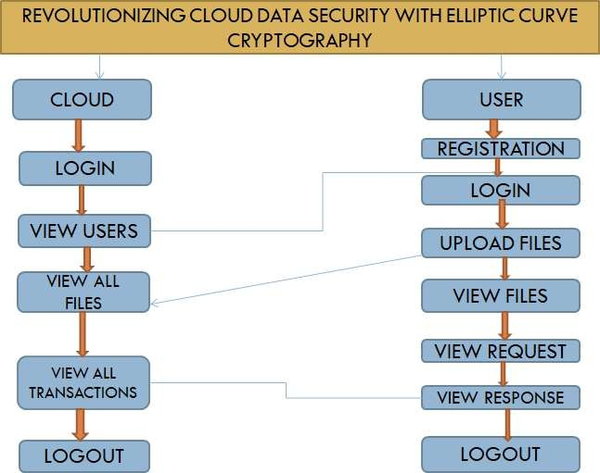

Fig.1.4.1 Flow graph

USERS:

Registration: The users will register with the details like name, email, password, contact, address and they will register.
Login: After registration the owner will login with email and password.

Encrypt Data: Here the user will enter text message and it will content into the encrypted file.

My file: After uploading the data user can view the data which is uploaded by him. View Files: user will view encrypted files
Requests: user request for key to decrypt the files

Decrypt data: By using the key data user will decrypt the file. Logout: User will logout from the portal.

CLOUD:

Login: The cloud will login with default creditionals. View users: The user can view all the users,
View transaction: The cloud can view all the files sent and received by users. Logout: cloud will logout from the portal.
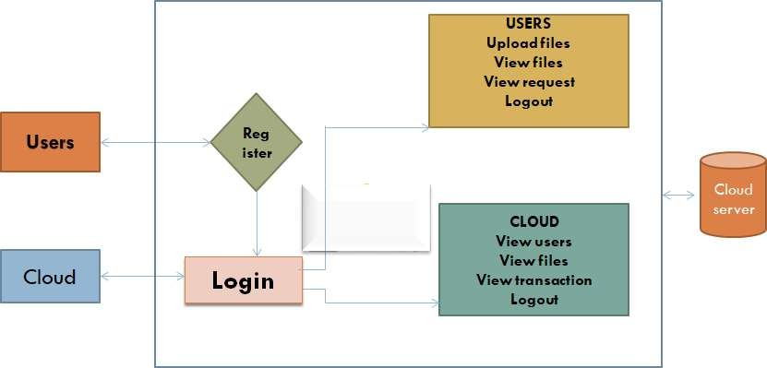

Fig.1.4.2: Working Principal

Advanced encryption standard (AES):

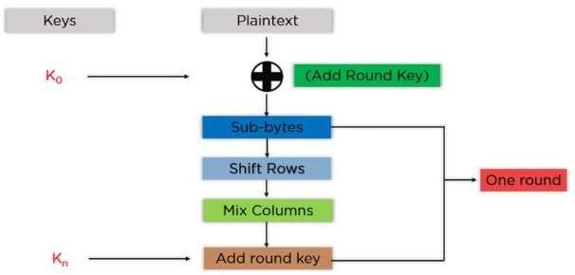

Fig.1.4.3: overview of the key elements of the AES algorithm

AES operates on a 4×4 byte matrix called the state array, and processes the input data block (usually 128 bits) over multiple rounds depending on the key size.

Workflow Steps (for each block of plaintext):

Key Expansion
      - The original encryption key is expanded into (Nr + 1) round keys.
      - For AES-128, there are 10 rounds, so 11 round keys are generated.

Initial Round
      - Add RoundKey: Perform bitwise XOR between the state array and the
first round key.

Main Rounds (Repeated Nr – 1 times)
Each round consists of the following 4 steps:

SubBytes:
        - Each byte in the state is substituted using an S-box (Substitution box) to add non-linearity.

ShiftRows:
        - The rows of the state array are cyclically shifted left (each row is shifted more than the previous one).

MixColumns:
        - Each column is mixed using a fixed matrix transformation, enhancing diffusion.

AddRoundKey:
        - Another XOR operation between the state and the corresponding round key.

Final Round (No Mix Columns)
      - SubBytes
      - ShiftRows
      - AddRoundKey

Output
      - The final state array after all rounds becomes the ciphertext block.

ECC Algorithm Workflow:
ECC is an asymmetric encryption technique based on the algebraic structure of elliptic curves over finite fields. It uses two keys: a public key (known to others) and a private key (kept secret), and is primarily used for key exchange, digital signatures, and encryption.

ECC is an alternative to the Rivest-Shamir-Adleman (RSA) cryptographic algorithm and is most often used for digital signatures in cryptocurrencies, such as Bitcoin and Ethereum, as well as one-way encryption of emails, data and software.
An elliptic curve is not an ellipse, or oval shape, but it is represented as a looping line intersecting two axes, which are lines on a graph used to indicate the position of a point. The curve is completely symmetric, or mirrored, along the x-axis of the graph.
Public key cryptography systems, like ECC, use a mathematical process to merge two distinct keys and then use the output to encrypt and decrypt data. One is a public key that is known to anyone, and the other is a private key that is only known by the sender and receiver of the data.

ECC generates keys through the properties of an elliptic curve equation instead of the traditional method of generation as the product of large prime numbers. From a cryptographic perspective, the points along the graph can be formulated using the following equation:
y²=x³ + ax + b

ECC is like most other public key encryption methods, such as the RSA algorithm and Diffie-Hellman. Each of these cryptography mechanisms uses the concept of a one-way, or trapdoor, function. This means that a mathematical equation with a public and private key can be used to easily get from point A to point B. But, without knowing the private key and depending on the key size used, getting from B to A is difficult, if not impossible, to achieve.
ECC is based on the properties of a set of values for which operations can be performed on any two members of the group to produce a third member, which is derived from points where the line intersects the axes as shown with the green line and three blue dots in the below diagram labeled A, B and C. Multiplying a point on the curve by a number produces another point on the curve (C). Taking point C and bringing it to the mirrored point on the opposite side of the x-axis produces point D. From here, a line is drawn back to our original point A, creating an intersection at point E. This process can be completed n number of times within a defined max value. The n is the private key value, which indicates how many times the equation should be run, ending on the final value that is used to encrypt and decrypt data. The maximum defined value of the equation relates to the key size used.

Basic Concept

An elliptic curve is defined by an equation:

y²=x³ + ax + b

over a finite field, where a and b are constants that define the curve.

ECC Workflow for Key Generation, Encryption, and Decryption

- Key Generation
  - Private Key (d): A randomly chosen large number.
  - Public Key (Q): Calculated using:

Q=d×GQ =

where:

G is a base point on the curve (a publicly known constant).

× denotes elliptic curve point multiplication.

Encryption (Sender's Side)

To encrypt a message using the receiver’s public key Q:
- Encode the plaintext message M as a point PM on the elliptic curve.
- Choose a random number k.
- Compute:
  - C1=k×G
  - C2=PM+k×Q
- The ciphertext is the pair (C1,C2)

Decryption (Receiver's Side)

To decrypt the received pair (C1,C2):

- Use the private key d to compute: d×C1=k×Q
- Recover the original message point: PM=C2−(d×C1)
- Decode PM back to plaintext.

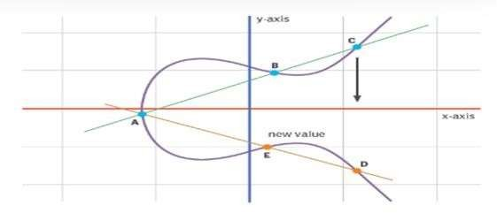

Fig.1.4.4: Elliptic curve showing three point intersection

Why ECC?

Feature Benefit

Smaller Key Size - Same security with smaller keys (e.g., 256-bit ECC ≈ 3072-bit RSA)

Efficiency - Faster computation and less memory

Security -
Harder to break with brute force due to the Elliptic Curve Discrete Logarithm Problem (ECDLP)

AES (Advanced Encryption Standard) provides fast and secure symmetric encryption for data confidentiality. ECC (Elliptic Curve Cryptography) offers strong asymmetric encryption with smaller key sizes and lower computational overhead. Combining AES and ECC enhances security by using ECC for secure key exchange and AES for efficient data encryption. Together, they provide a robust and scalable solution for modern data protection needs.
The AES-ECC hybrid algorithm combines the speed of symmetric encryption with the security of asymmetric cryptography. AES ensures fast and efficient data encryption, ideal for large data volumes. ECC provides strong key exchange and authentication with smaller key sizes. Together, they offer a balanced trade-off between performance and security. The hybrid model protects against brute-force and quantum-related threats. ECC securely shares AES keys over insecure channels, eliminating key distribution issues. This integrated approach enhances confidentiality, integrity, and scalability. Overall, AES-ECC encryption is well-suited for modern, resource-constrained secure communication systems. The use of ECC for key exchange removes the major vulnerability of symmetric key sharing. It ensures that even if the communication channel is compromised, the encryption key remains secure AES then provides rapid data encryption and decryption, ensuring efficiency is not sacrificed.

CHAPTER 2

LITERATURE SURVEY

S. Rehman, N. Talat Bajwa M. A. Shah, A. O. Aseeri, and A. Anjum,‘‘Hybrid AES-ECC model for the security of data over cloud storage,’’Electronics, vol. 10, no. 21, p. 2673, Oct. 2021
In this study, researchers proposed a hybrid model that combines the Advanced Encryption Standard (AES) and Elliptic Curve Cryptography (ECC) to enhance data security in cloud storage environments. The AES algorithm was employed for encrypting data, while ECC was used for secure key generation. The hybrid approach achieved a balance between strong encryption and computational efficiency, making it suitable for cloud security applications. The model outperformed traditional encryption methods in terms of speed and security, particularly for resource-constrained environments like mobile cloud storage.

S. K. Dwivedi, R. Amin, J. D. Lazarus, and V. Pandi, ‘‘Blockchain based electronic medical records system with smart contract and consensus algorithm in cloud environment,’’ Secur. Commun. Netw., vol. 2022, pp. 1–10, Sep. 2022.
This research focused on the integration of blockchain technology to secure electronic medical records (EMRs) in cloud storage. By leveraging a decentralized blockchain ledger, the study proposed a method to store encryption keys and metadata for medical data in a tamper-resistant manner. Blockchain consensus mechanisms were used to ensure data integrity and prevent unauthorized access. The study demonstrated improved security in medical cloud systems while maintaining data privacy and accessibility for healthcare professionals.

G. Habib, S. Sharma, S. Ibrahim, I. Ahmad, S. Qureshi, and M. Ishfaq, ‘‘Blockchain technology: Benefits, challenges, applications, and integration of blockchain technology with cloud computing,’’ Future Internet, vol. 14, no. 11, p. 341, Nov. 2022.

A Fine-Grained Access Control (FGAC) system using fuzzy logic was proposed to enhance data security in cloud environments. The system generated public, private, and session keys for data encryption, and biometric authentication was used to verify access. The solution was aimed at protecting sensitive data from unauthorized access by leveraging multiple security mechanisms, including multi-level encryption, key management, and biometric authentication. This approach ensured robust protection against cyberattacks.

. K. Bhalla, D. Koundal, S. Bhatia, M. Khalid Imam Rahmani, and M. Tahir, ‘‘Dynamic encryption and secure transmission of terminal data files,’’ Comput., Mater. Continua, vol. 71, no. 1, pp. 1221–1232, 2022
This study introduced a novel Lightweight Cryptographic Algorithm (NLCA) specifically designed for cloud environments. The NLCA is a 16-byte block cipher that operates with a 16-byte key. The algorithm demonstrated faster encryption speeds while maintaining high levels of security, particularly for cloud services where efficiency and resource optimization are critical. The comparative analysis against existing algorithms showed that NLCA provided enhanced data protection with minimal computational overhead【 5†source】.

I. Keshta, Y. Aoudni, M. Sandhu, A. Singh, P. A. Xalikovich, A. Rizwan, M. Soni, and S. Lalar, ‘‘Blockchain aware proxy re-encryption algorithm based data sharing scheme,’’ Phys. Commun., vol. 58, Jun. 2023,
Art. no. 102048. Researchers developed a Non-Deterministic Cryptographic Scheme (NCS) to address data confidentiality and privacy concerns in cloud computing. The scheme incorporates the Sliding Window Algorithm (SWA) and the Linear Congruential Generator (LGC), making it highly resistant to data analysis attacks. The scheme was compared to widely used algorithms such as AES, RSA, and DES, and it exhibited superior performance in terms of execution time and encryption. strength. The NCS provides a scalable and efficient encryption solution for securing cloud data.

CHAPTER 3

EXISTING METHOD
The existing system for cloud data security primarily relies on traditional encryption methods, which often use static keys for data protection.
These methods face significant vulnerabilities, such as compromised encryption keys and centralized key management, leading to unauthorized access and data breaches. Additionally, static keys can allow attackers to decrypt multiple files if one key is compromised.
The lack of robust security during data transmission further exacerbates these issues. Overall, traditional systems struggle with scalability and adaptability, making them inadequate for the dynamic nature of cloud computing environments, ultimately compromising data integrity and user trust.

Drawbacks:

      - Vulnerability to Key Compromise: Static encryption keys, once compromised, allow attackers to decrypt multiple files, exposing sensitive data.
      - Centralized Key Management Risks: Relying on centralized storage for encryption keys increases the risk of unauthorized access and single points of failure.
      - Limited Adaptability: Traditional systems lack flexibility, making it difficult to respond to evolving security threats and changing user requirements.
      - Inadequate Security During Transmission: Existing methods often fail to secure encryption keys during data transmission, increasing the risk of interception.
      - Scalability Issues: As the volume of data grows, traditional encryption methods may struggle to efficiently manage and secure data across diverse cloud environments.

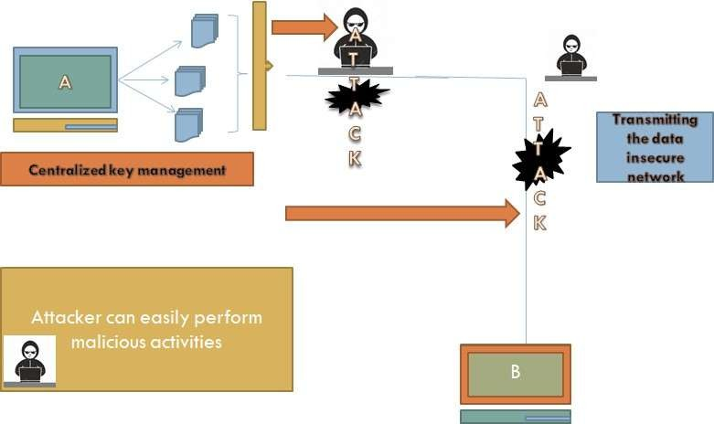

Fig.3.1.1: Existing method diagram

PROPOSED METHOD:

The proposed system introduces a hybrid approach to cloud data security by combining dynamic Advanced Encryption Standard (AES) encryption with blockchain technology. This innovative solution generates unique, constantly changing encryption keys for each file, significantly enhancing file-level security and reducing the risk of mass decryption from key compromise. Additionally, blockchain technology securely stores encryption keys in a decentralized manner, improving key management and integrity. By leveraging Elliptic Curve Cryptography (ECC) for secure key transmission, the system ensures robust protection against unauthorized access. Overall, this approach aims to provide scalable, adaptable, and trustworthy security for sensitive data in cloud environments.

Advantages:

      - Enhanced Security: Dynamic AES encryption ensures each file has a unique and changing encryption key, significantly reducing the risk of mass decryption if a key is compromised.
      - Decentralized Key Management: Utilizing blockchain technology for key storage enhances security and integrity, mitigating risks associated with centralized key management.
      - Robust Protection During Transmission: The integration of Elliptic Curve Cryptography (ECC) secures encryption keys during data transmission, preventing unauthorized interception.
      - Scalability and Adaptability: The system is designed to adapt to evolving security threats and manage increasing data volumes efficiently.
      - User Trust and Transparency: The use of blockchain fosters trust by providing transparency and accountability in data management and encryption processes.
      - Streamlined Key Management: Users can efficiently manage numerous dynamic keys, enhancing usability without sacrificing security.

PROPOSED METHOD DIAGRAM:

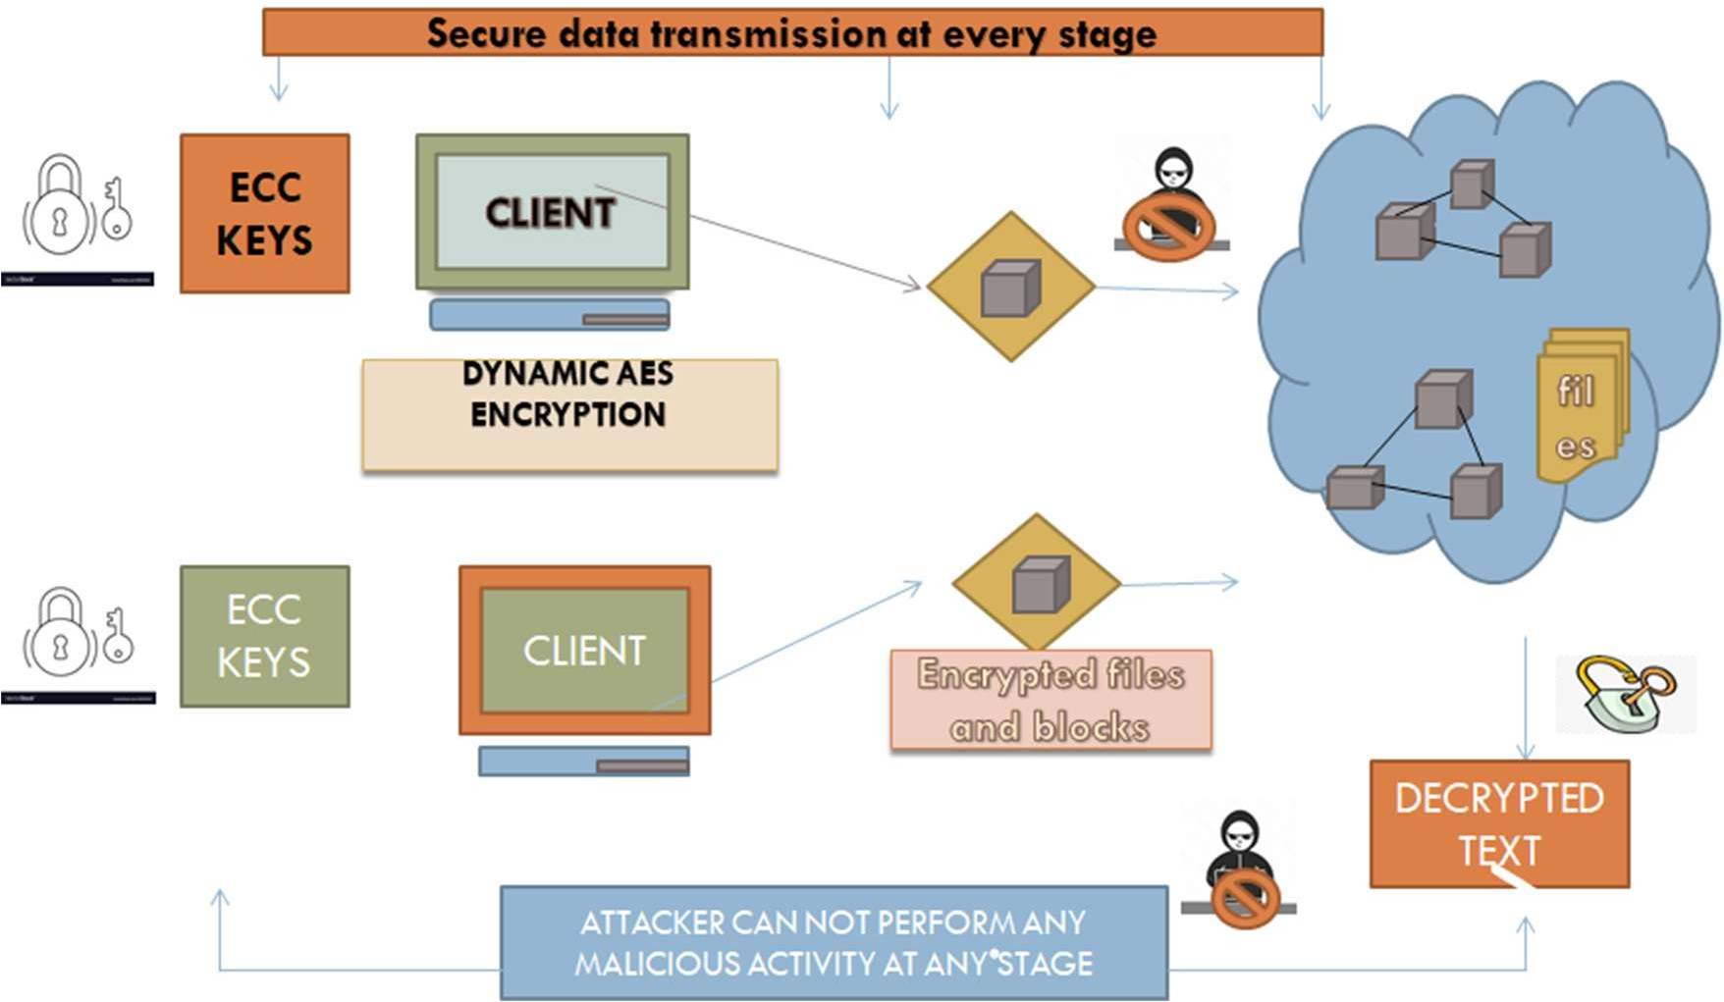
Fig 3.2.2: Proposed method diagram

By leveraging Elliptic Curve Cryptography (ECC) for secure key transmission, the system ensures robust protection against unauthorized access. Overall, this approach aims to provide scalable, adaptable, and trustworthy security for sensitive data in cloud environments.

PROPOSED BLOCK DIAGRAM:
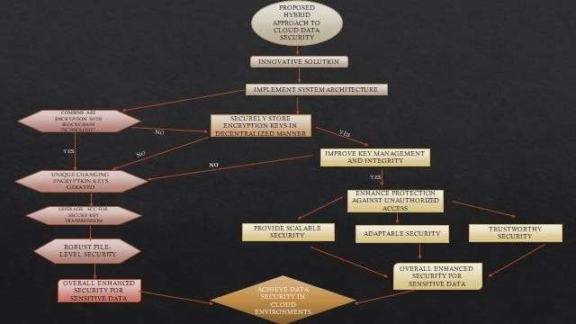

Fig 3.2.3 Proposed Block Diagram

CHAPTER 4
HARDWARE AND SOFTWARE REQUIREMENTS

SOFTWARE REQUIREMENTS:
    - Operating System : Windows 7/8/10
    - Server side Script : HTML, CSS, Bootstrap & JS
    - Programming Language : Python
    - Libraries : Django, Pandas, Mysql.connector, Os,

Smtplib,Numpy
    - IDE/Workbench : VS Code
    - Technology : Python 3.6+
    - Server Deployment : Xampp Server
    - Database : MySQL

HARDWARE REQUIREMENTS:
    - Processor : I3/Intel Processor
    - Hard Disk :160GB
    - Key Board : Standard Windows Keyboard
    - Mouse : Two or Three Button Mouse
    - Monitor : SVGA
    - RAM : 8GB

SOFTWARE ENVIRONMENT
    - INTRODUCTION TO PYTHON
Python is a versatile, high-level programming language known for its readability and ease of use, widely used in fields like web development, data science, and machine learning. Python is a very popular general-purpose interpreted, interactive, object- oriented, and high-level programming language. Python is dynamically-typed and garbage-collected programming language. It was created by Guido van Rossum during 1985-1990. Like Perl, Python source code is also available under the GNU General

Public License (GPL). Today, Python is very high in demand and all the major companies are looking for great Python Programmers to develop websites, software components, and applications or to work with Data Science, Al, and ML. technologies.
In 2022, there is a high shortage of Python Programmers whereas market demands more number of Python Programmers due to it's application in Machine Learning. Artificial Intelligence etc.
The front-end of the application is built using a combination of HTML, CSS, Bootstrap, and JavaScript. HTML provides the basic structure of the web pages, while CSS is used for styling and layout. Bootstrap helps create responsive and mobile-friendly interfaces with pre-designed components. JavaScript enhances user interactivity and dynamic content rendering within the web pages.
--Script: Scripts are reusable. Basically, a script in a text file containing the statements that comprise a Python program. Once you have created the script, you can execute it over and over without having to retype it each time
Scripts are editable. Perhaps, more importantly, you can make different versions of the script by modifying the statements from one file to the next using a text editor. Then you can execute each of the individual versions. In this way, it is easy to create different programs with a minimum amount of typing.
You will need a text editor. Just about any text editor will suffice for creating Python script files. You can use Microsoft Notepad, Microsoft WordPad, Microsoft Word, or just about any word processor if you want to perform.
Difference between a script and a program
--Script: Scripts are distinct from the core code of the application, which is usually written in a different language, and are often created or at least modified by the end-user Scripts are often interpreted from source code or byte code, whereas the applications they control are traditionally compiled to native machine code.
--Program: The program has an executable form that the computer can use directly to execute the instructions. The same program in its human-readable source code form, from which executable programs are derived (e.g., compiled).
--Python: Python is a high-level, interpreted, general-purpose programming language known for its simplicity, readability, and versatility. Developed by Guido van Rossum and first released in 1991, Python emphasizes code readability and allows developers to express concepts in fewer lines of code compared to other programming languages. It supports multiple programming paradigms including object-oriented, procedural, and

functional programming. Python is widely used in web development, data science, machine learning, automation, scripting, and more due to its vast standard library and large community support.

PYTHON CONCEPTS
-Variables and Data Types: Python allows dynamic typing, meaning variables don't need explicit declarations. Common data types include integers, floats, strings, lists, tuples, sets, and dictionaries.
-Control Structures: Python supports conditional statements (if, elif, else) and loops (for, while) to control the flow of execution.
-Functions: Functions in Python are defined using the def keyword. They promote code reuse and modularity. Python also supports anonymous functions using lambda.
-Object-Oriented Programming (OOP): Python is an object-oriented language that supports concepts like classes, objects, inheritance, encapsulation, and polymorphism.
-Modules and Packages: Python code can be organized into modules and packages. This promotes reuse and better code organization. The import statement is used to include external modules.
-Exception Handling: Python provides robust error handling using try, except, finally, and raise blocks to manage runtime exceptions gracefully.
-File Handling: Python allows easy interaction with files using built-in functions such as open(), read(), write(), and close().
-Libraries and Frameworks: Python has a rich ecosystem of libraries like NumPy, Pandas, Matplotlib, and frameworks like Django and Flask, making it suitable for diverse applications.
-List Comprehensions and Generators: Python offers elegant ways to create and manage collections using list comprehensions and generators for memory-efficient looping.
-Interpreted Language: Python code is executed line-by-line by an interpreter, which makes it easy to debug and run scripts quickly.
History of python:
Python was developed by Guido van Possum in the late eighties and early nineties at the National Research Institute for Mathematics and Computer Science in the Netherlands. Python is derived from many other languages, including ABC, Modula-3, C, C++, Algol-

68, Smalltalk, and UNIX shell and other scripting languages. Python is copyrighted. Like Perl, Python source code is now available under the GNU General Public License (GPL). Python is now maintained by a core development team at the institute, although Guido van Possum still holds a vital role in directing its progress.

FEATURES OF PYTHON
--Easy-to-learn- Python has few keywords, simple structure, and a clearly defined syntax. This allows the student to pick up the language quickly.
--Easy-to-read-Python code is more clearly defined and visible to the eyes. Easy-to-maintain - Python's source code is fairly easy-to-maintain.
--A broad standard library
--Python's bulk of the library is very portable and cross-platform compatible on UNIX, Windows, and Macintosh.
--Interactive Mode Python has support for an interactive mode which allows interactive testing and debugging of snippets of code.
--Portable- Python can run on a wide variety of hardware platforms and has the same interface on all platforms.
--Extendable you can add low-level modules to the Python interpreter. These modules enable programmers to add to or customize their tools to be more efficient.
--Databases - Python provides interfaces to all major commercial databases.
--GUI Programming Python supports GUI applications that can be created and ported to many system calls, libraries and windows systems, such as Windows MFC, Macintosh, and the X Window system of Unix.
--Scalable - Python provides a better structure and support for large programs than shell scripting. Apart from the above-mentioned features, Python has a big list of good features, few are listed below "It supports functional and structured programming methods as well as OOP ". It can be used as a scripting language or can be compiled to byte-code for building large applications. " It provides very high-level dynamic data types and supports dynamic type checking. " IT supports automatic garbage collection. " It can be easily integrated with C, C++, COM, ActiveX, CORBA, and Java.

DATA TYPES:
Python provides a rich set of built-in data types that enable developers to store, process, and manage various kinds of information efficiently. These data types are categorized into different groups. Numeric types include int for whole numbers, float for decimal numbers, and complex for complex numbers with real and imaginary parts. The text type in Python is str, which is used to represent sequences of Unicode characters such as words, sentences, or any form of textual data. Sequence types like list, tuple, and range are used to store collections of items. While list is mutable (can be changed), tuple is immutable (cannot be changed once defined), and range is used to generate a sequence of numbers.
Python also includes set types, such as set and frozenset, which are collections of unordered, unique items. Mapping types are represented by dict, which stores key-value pairs, allowing efficient retrieval of data. Additionally, Python supports Boolean type bool, which holds only two values: True or False, often used in logical operations and control flow. For handling binary data like files or images, Python provides binary types such as bytes, bytearray, and memoryview. These diverse data types make Python extremely versatile and suitable for a wide range of programming tasks.

PYTHON PACKAGES:
In Python, a package is a way to organize and structure related modules (Python files) into a single directory hierarchy. A package is simply a folder that contains a special file named init.py, which tells Python to treat the directory as a package. This allows for better code organization and helps manage large projects by grouping related functionality together.
Packages can contain sub-packages and modules, making it easier to reuse and maintain code across multiple files. For example, Python's standard library contains many packages like os, math, email, and third-party packages like numpy or django can be installed using pip. You can import and use them in your programs to add advanced features without writing everything from scratch.
Django: Django is a high-level Python web framework that enables the rapid development of secure and maintainable web applications. It follows the Model-View- Template (MVT) architecture and provides built-in features like user authentication, admin panels, and database management. Django promotes reusable code and a "don’t repeat yourself" (DRY) principle, making it ideal for developing full-fledged websites efficiently.

-Pandas: Pandas is a powerful data manipulation and analysis library. It provides data structures like DataFrames and Series that are essential for handling structured data. Pandas is commonly used in data science and analytics for tasks such as filtering, grouping, merging, and aggregating large datasets with ease.
-mysql.connector: mysql.connector is a Python library used to connect Python applications with MySQL databases. It allows executing SQL queries directly from Python code, enabling database operations like inserting, updating, deleting, and retrieving data. This library is essential for building dynamic, data-driven applications.
-Os: The os module in Python provides functions to interact with the operating system. It is used to perform tasks such as reading or writing files, navigating directories, managing environment variables, and executing system commands. It plays a key role in file handling and system-level programming.
-Smtplib: Smtplib is a built-in Python module used for sending emails using the Simple Mail Transfer Protocol (SMTP). It allows your Python application to send automated emails, such as not ifications, password resets, or verification messages, which is useful in web and enterprise applications.
-NumPy: NumPy (Numerical Python) is a fundamental package for scientific computing in Python. It provides support for multi-dimensional arrays, mathematical functions, linear algebra, and more. NumPy is widely used in data science, machine learning, and any application that involves numerical computations.
XAMPP is a free software that helps you run a local web server on your computer. It includes important tools like Apache (to run websites), MySQL (to store data in databases), and phpMyAdmin (to manage the database easily through a browser). Even though it's mainly made for PHP, you can also use it to manage MySQL databases in Python projects.
With XAMPP, you can test your website or application offline before putting it on the internet. It's easy to install and comes with a control panel where you can start or stop services like Apache and MySQL with just one click. It’s perfect for students, developers, and anyone learning web development.
MYSQL DATABASE: MySQL is a popular open-source relational database management system (RDBMS) used to store, manage, and organize data. It works by storing data in tables, which consist of rows and columns, making it easy to retrieve and manage large amounts of structured information. MySQL uses Structured Query Language (SQL) to perform operations like inserting, updating, deleting, and querying data.

MySQL is widely used in web development and works well with programming languages like Python, PHP, and Java. In Python, you can connect to MySQL using libraries such as mysql.connector to build dynamic, data-driven applications. MySQL is reliable, fast, and supports features like user access control, relationships between tables (foreign keys), and data integrity.

INTRODUCTION TO VISUAL STUDIO CODE

- Visual Studio Code (often abbreviated as VS Code) is a free and open-source code editor developed by Microsoft. It is widely used by developers for creating and editing code across a variety of programming languages. Some key features of VS Code include: Built-in support for Git version control Syntax highlighting and auto-completion for many programming languages Integrated debugging capabilities. Customizable user interface with extensions and themes
- Cross-platform support for Windows, macOS, and Linux VS Code has become a popular choice for developers due to its ease of use, extensive customization options, and broad range of extensions and plugins that are available for download. It is also highly optimized for performance, making it a great choice for large code bases or resource-intensive projects. Installation of Visual Studio Code:
- Go to the Visual Studio Code website at https://code.visualstudio.com/ and click on the "Download" button for your operating system (Windows, macOS, or Linux).
- Once the download is complete, run the installer and follow the instructions to complete the installation process. On Windows, you may need to give permission to the installer to make changes to your device.
- Visit: https://code.visualstudio.com/download

  - 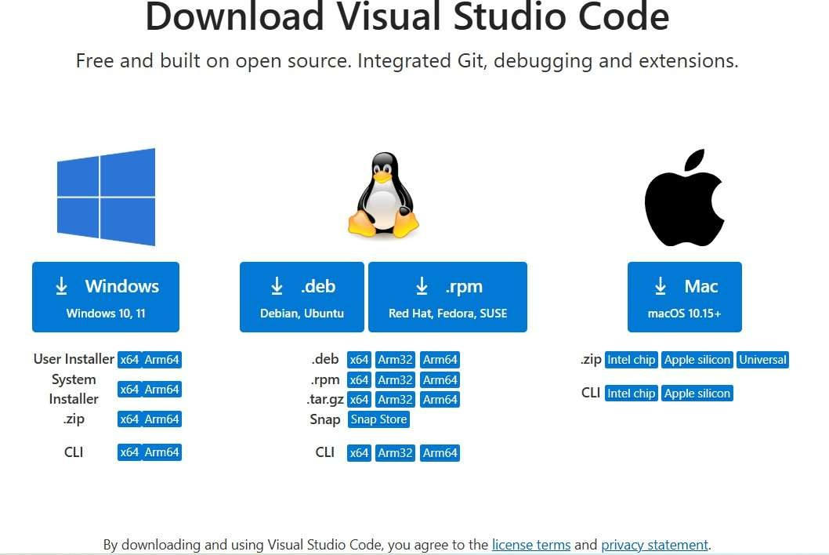
- After the installation is complete, launch Visual Studio Code by clicking on the icon on your desktop or searching for it in your applications folder.
- When you first launch Visual Studio Code, you will see a welcome screen with a few options. You can choose to open an existing folder or file, create a new file, or customize your settings
- Visual Studio Code comes with a basic set of features, but you can customize it with extensions. To browse and install extensions, click on the "Extensions" icon in the left-hand sidebar (it looks like a square with four rectangles inside) and search for the extensions you want to install.

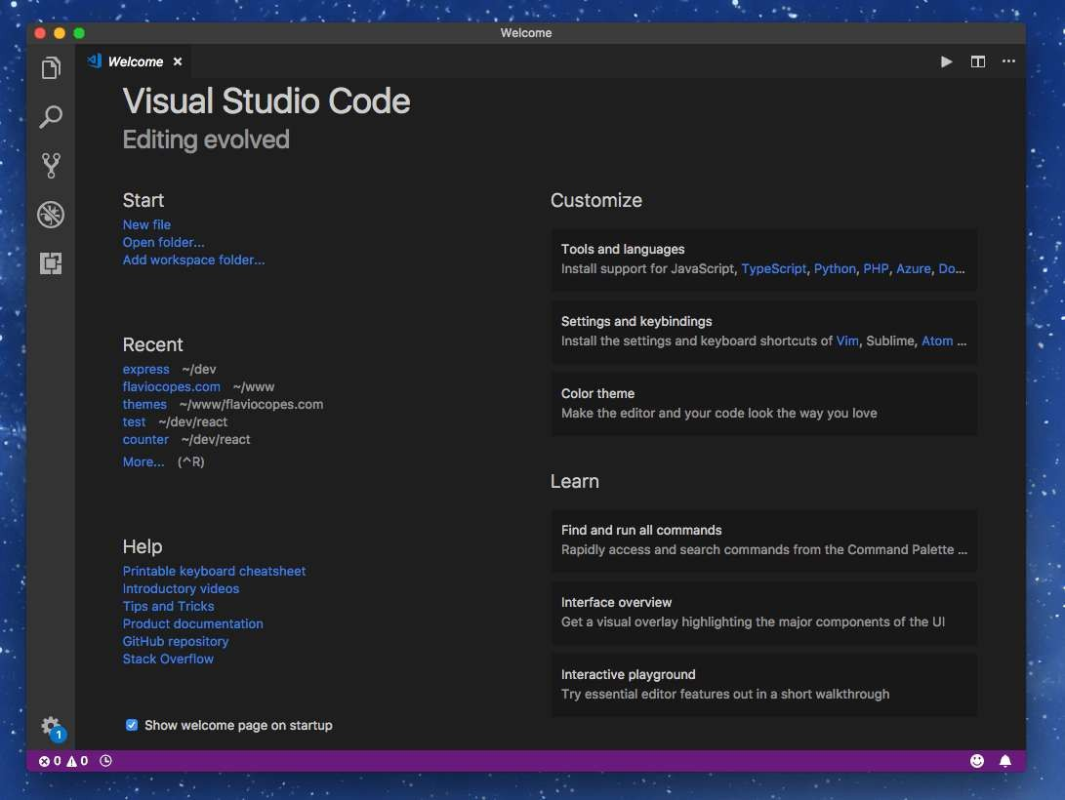

- Once you have installed extensions, you may need to restart Visual Studio Code to activate them.
- You're now ready to start using Visual Studio Code!
- To open a project or file in Visual Studio Code, use the "Open Foller" or "Open File" options under the "File" menu.
- Next from the menu select "Terminal" and click on New Terminal as below:

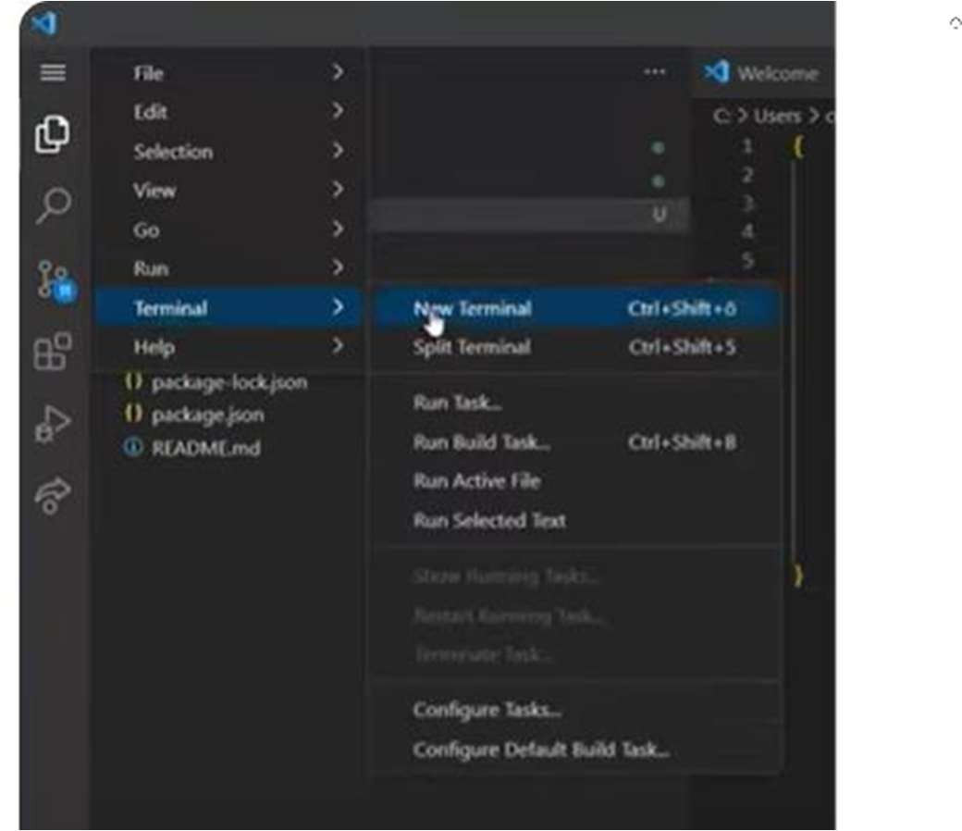

- It will create a terminal at the bottom of the screen. output in the terminal as below:
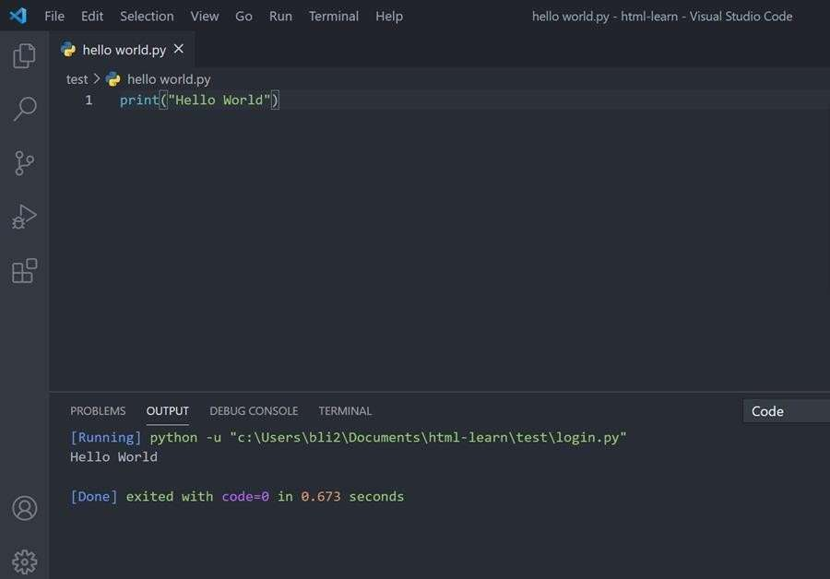

HARDWARE ENVIRONMENT:
Hardware requirements refer to the minimum or recommended physical components of a computer system needed to install, run, and operate a software application or project successfully. These requirements typically include specifications for the processor (CPU), memory (RAM), storage space (hard disk), input devices (keyboard, mouse), and output devices (monitor). Ensuring that the hardware meets these requirements helps the software function efficiently without performance issues or system crashes.
The hardware requirements listed are the minimum specifications needed to run the project or application smoothly.
A system with an Intel Core i3 processor or any equivalent Intel processor ensures decent performance for executing programming code, handling databases, and running web servers like XAMPP.
A hard disk capacity of 160GB is sufficient to store the project files, necessary software installations (like Python, Django, MySQL), and some additional data or documents.
Other essential input and output devices include a standard Windows keyboard for typing code and commands, and a two or three-button mouse for easy navigation and control.
A Super Video Graphics Array (SVGA) monitor offers a clear display for a better user experience during development and testing.
Additionally, having 8GB of RAM ensures smooth multitasking, faster application execution, and efficient handling of databases and development tools without system lag.

CHAPTER 5 FEASIBILITY STUDY
The feasibility of the project is analysed in this phase and business proposal is put forth with a very general plan for the project and some cost estimates. During system analysis the feasibility study of the proposed system is to be carried out. This is to ensure that the proposed system is not a burden to the company. For feasibility analysis, some understanding of the major requirements for the system is essential.
Three key considerations involved in the feasibility analysis are
- ECONOMICAL FEASIBILITY
- TECHNICAL FEASIBILITY
- SOCIAL FEASIBILITY

ECONOMICAL FEASIBILITY:
This study is carried out to check the economic impact that the system will have on the organization. The amount of fund that the company can pour into the research and development of the system is limited. The expenditures must be justified. Thus the developed system as well within the budget and this was achieved because most of the technologies used are freely available. Only the customized products had to be purchased.

TECHNICAL FEASIBILITY:
This study is carried out to check the technical feasibility, that is, the technical requirements of the system. Any system developed must not have a high demand on the available technical resources. This will lead to high demands on the available technical resources. This will lead to high demands being placed on the client. The developed system must have a modest requirement, as only minimal or null changes are required for implementing this system.

SOCIAL FEASIBILITY:

The aspect of study is to check the level of acceptance of the system by the user. This includes the process of training the user to use the system efficiently. The user must not

feel threatened by the system, instead must accept it as a necessity. The level of acceptance by the users solely depends on the methods that are employed to educate the user about the system and to make him familiar with it. His level of confidence must be raised so that he is also able to make some constructive criticism, which is welcomed, as he is the final user of the system.

CHAPTER 6

SYSTEM DESIGN

SYSTEM STRUCTURE

System design is the process of planning and organizing the structure of a software or hardware system to ensure it meets specific requirements and functions efficiently. It involves defining the overall architecture, including the key components, their roles, how they interact with each other, and how data flows throughout the system. This phase focuses on transforming user requirements into a blueprint that guides the development process, covering both high-level architecture (like system modules and their interactions) and low-level design (like algorithms and data structures).
A well-thought-out system design ensures that the system is scalable, secure, maintainable, and reliable. It addresses key considerations such as performance optimization, data storage, communication between components, and fault tolerance. In security-oriented projects like cloud data protection using Elliptic Curve Cryptography (ECC), system design plays a critical role in ensuring encrypted data is safely handled at every stage—encryption, key management, cloud storage, and retrieval—while maintaining user accessibility and compliance with security standards.


Fig 6.1 System Structure Design

ARCHITECTURE:

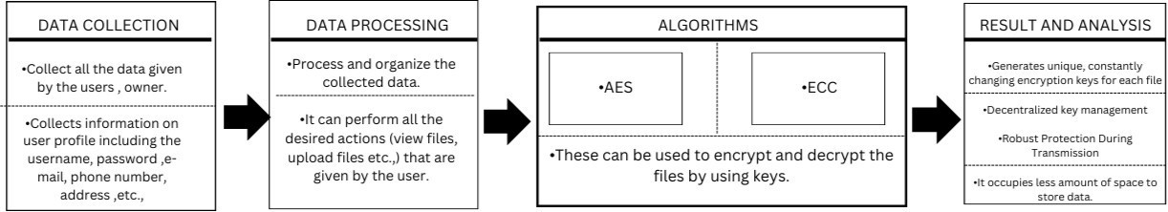

Fig.6.2 Architecture

UML DIAGRAMS
UML (Unified Modelling Language) diagrams are standardized visual representations used in software engineering to describe the structure and behavior of a system. UML is a standard language for specifying, visualizing, constructing, and documenting the artifacts of software systems, as well as for business modelling and other non-software systems. The UML represents a collection of best engineering practices that have proven successful in the modelling of large and complex systems. The UML is a very important part of developing objects-oriented software and the software development process. The UML uses mostly graphical notations to express the design of software projects.
Using UML helps project teams communicate, explore potential designs, and validate the architectural design of the software. As the strategic value of software increases foe many companies, the industry looks for techniques to automate the production of software and to improve quality and reduce cost and time-to-market. These techniques include component technology, visual programming, patterns and frameworks. Businesses also seek techniques to manage the complexity of systems as they increase in scope and scale. In particular, they recognize the need to solve recurring architectural problems, such as physical distribution, concurrency, replication, security, load balancing and fault tolerance. Additionally, the development for the world wide web, while making some things simpler, has exacerbated these architectural problems. The unified modelling language (UML) was designed to respond to these needs. Simply, system design refers to the process of defining the architecture, components, modules, interfaces, and data for a

system to satisfy specified requirements which can be done easily through UML diagrams.
Generally the contents of UML are as follows
In general , a UML diagram consists of the following features:
- Elements: These are the building blocks of UML diagrams and include:
  - Actors – Represent users or other systems interacting with the system.
  - Classes – Define objects with attributes and operations.
  - Objects – Instances of classes.
  - Components – Represent modular parts of the system.
  - Nodes – Represent hardware or runtime environments in deployment diagrams.
- Relationships: UML diagrams use different types of relationships to connect elements:
  - Association – A basic connection between elements.
  - Dependency – One element depends on another.
  - Generalization (Inheritance) – One element is a specialized version of another.
  - Aggregation and Composition – "Whole-part" relationships (composition is stronger).

    - Diagram-Specific Notations: Each UML diagram type has its own set of visual symbols:
    - Use Case Diagram: Ovals (use cases), stick figures (actors), and lines to represent interactions.
    - Class Diagram: Rectangles divided into class name, attributes, and methods.
    - Sequence Diagram: Lifelines, activation bars, and arrows for message flow.
    - Activity Diagram: Rounded rectangles (activities), diamonds (decisions), arrows (flow).
- Annotations and Constraints: Notes can be added to explain certain parts of the diagram. Constraints can define rules or conditions for elements or relationships.

USE CASE DIAGRAM:
A use case diagram in the Unified Modeling Language (UML) is a type of behavioral diagram defined by and created from a Use-case analysis. Its purpose is to present a graphical overview of the functionality provided by a system in terms of actors, their goals (represented as use cases), and any dependencies between those use cases. The main purpose of a use case diagram is to show what system functions are performed for which actor. Roles of the actors in the system can be depicted.
Use Case Diagrams are essential during the requirement analysis phase of a software project. They help capture what the system is supposed to do from the perspective of end- users. These diagrams are valuable for understanding user goals, designing features accordingly, and ensuring that the system delivers value to its users. They also serve as a communication bridge between stakeholders and developers.
Parts of use case diagram:
- Actors
  - Represent the users or external systems that interact with the system.
  - Can be primary actors (who initiate the interaction) or secondary actors (who provide support).
  - Represented by a stick figure icon placed outside the system boundary.
- System Boundary Boxes
  - Represent the scope of the system—what is included and what is external.
  - Shown as a rectangle that contains all the use cases.
  - Labeled with the system name at the top (e.g., Cloud Security System).
  - Actors and their interactions lie outside this box, while use cases are inside.
- Associations
  - Represent the interactions or communication between actors and use cases.
  - Shown as solid lines connecting actors to the use cases they participate in.
  - Example: A line connecting User to the Upload File use case.

- Include Relationship
  - Indicates that the behavior of one use case is always included in another.
  - Reusable behavior that multiple use cases might share.
  - Shown as a dashed arrow labeled <<include>>, pointing from the base use case to the included use case.
  - Example: Encrypt File <<include>> Generate ECC Key.
- Extend Relationship
  - Indicates optional or conditional behavior that extends the base use case.
  - Used for additional functionalities that may occur under certain conditions.
  - Shown as a dashed arrow labeled <<extend>>, pointing from the extending use case to the base use case.
  - Example: Login <<extend>> Forgot Password.
- Generalization
  - Represents inheritance between actors or use cases.
  - One actor or use case inherits the behavior of another.
  - Shown as a solid line with a hollow triangle, pointing from the specialized to the generalized element.
  - Example: Admin → User (Admin inherits all user capabilities plus more).
-Identify the System
-Identify the Use Cases
-Identify the Actors
-Connect Actors to Use Cases
-Add Relationships (if needed)
-Review your use case for completeness.

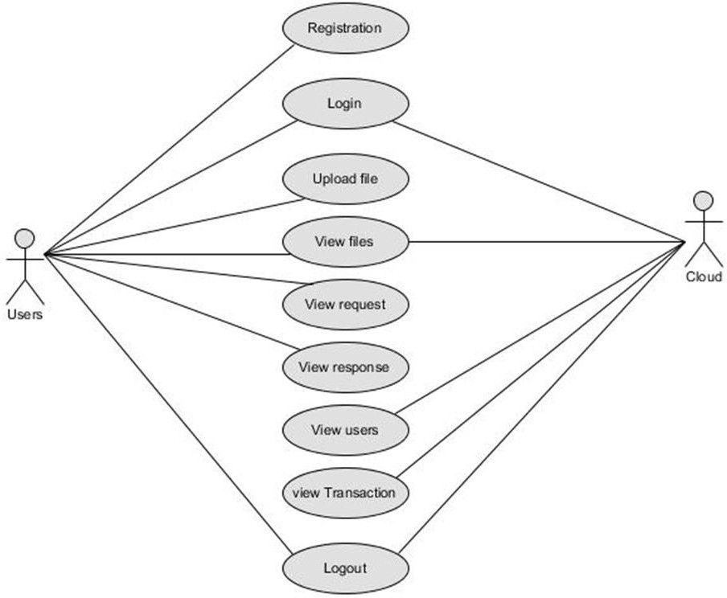

Fig.6.3.1 Use Case Diagram

CLASS DIAGRAM:
In software engineering, a class diagram in the Unified Modelling Language (UML) is a type of static structure diagram that describes the structure of a system by showing the system's classes, their attributes, operations (or methods), and the relationships among the classes. It explains which class contains information.
Classes: In a class diagram, a class is a core element that defines the structure and behavior of objects in the system. It contains attributes (data) and methods (functions) that describe what the object knows and can do. Classes are depicted as rectangles divided into three compartments: the top for the class name, the middle for attributes, and the bottom for methods. In object-oriented design, classes act as blueprints for creating instances (objects), helping in organizing code and ensuring modularity and reusability.

Interfaces: These titled boxes represent interfaces in the system and contain information about the name of the interfaces and its methods.Relationship lines that model the relationships between classes and interfaces in the system.
Dependency: A dotted line with an open arroehead that shows one entity depends on the behaviour of another entity. Typical usages are to represent that one class instantiates another or that it uses the other as an input parameter.
Aggregation: Represented by an association line with a hollow diamond at the tail end. An aggregation models the notion that one object uses another object without “owning” it and thus is not responsible for its creation or destruction.
Inheritance: A solid line with a solid arrowhead that points from a sub-class to a super class or from a sub-interface to its super-interface.
Implementation: A dotted line with a solid arrowhead that points from a class to the interface that it implement.
Composition: Represented by an association line with a solid diamond at the tail end. A composition models the notion of one object “owning” another and thus being responsible for the creation and destruction of another object.
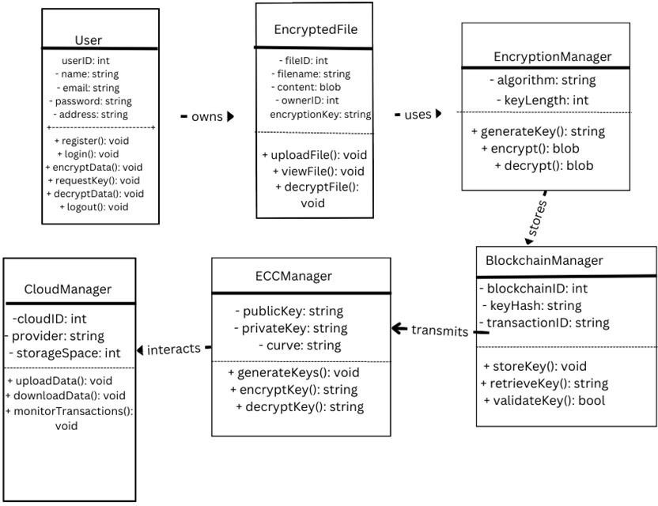

Fig.6.3.2 Class Diagram

SEQUENCE DIAGRAM:
A sequence diagram in Unified Modelling Language (UML) is a kind of interaction diagram that shows how processes operate with one another and in what order. It is a construct of a Message Sequence Chart. Sequence diagrams are sometimes called event diagrams, event scenarios, and timing diagrams. And it depicts the sequence of actions that occur in a system. The invocation of methods in each object, and the order in which the invocation occurs is captured in a Sequence diagram. This makes the Sequence diagram a very useful tool to easily represent the dynamic behaviour of a system.
-Elements of sequence diagram The sequence diagram is an element that is used primarily to showcase the interaction that occurs between multiple objects. This interaction will be shown over certain period of time. Because of this, the first symbol that is used is one that symbolizes the object.
-Lifeline A lifeline will generally be generated, and it is a dashed line that sits vertically, and the top will be in the form of a rectangle. This rectangle is used to indicate both the instance and the class. If the lifeline must be used to denote an object, it will be underlined
-Messages To showcase an interaction, messages will be used. These messages will come in the form of horizontal arrows, and the messages should be written on top of the arrows. If the arrow has a full head, and it's solid, it will be called a synchronous call. If the solid arrow has a stick head, it will be an asynchronous call. Stick heads with dash arrows are used to represent return messages
Objects: Objects will also be given the ability to call methods upon themselves, and they can add net activation boxes. Because of this, they can communicate with others to show multiple levels of processing. Whenever an object is eradicated or erased from memory, the "X" will be drawn at the lifeline's top, and the dash line will not be drawn beneath it. This will often occur as a result of a message. If a message is sent from the outside of the diagram, it can be used to define a message that comes from a circle that is filled in. Within a UML. based model, a Super step is a collection of steps which result from outside stimuli.
Steps to Create a Sequence Diagram
-Set the context for the interaction, whether it is a system, subsystem, operation or class

-Set the stage for the interaction by identifying which objects play a role in interaction.

-Set the lifetime for each object.
- Start with the message that initiates the interaction.
- Visualize the nesting of messages or the points in time during actual computation.
- Specify time and space constraints, adorn each message with timing mark and attach suitable time or space constraints.
-Specify the flow of control more formally, attach pre and post conditions to each message

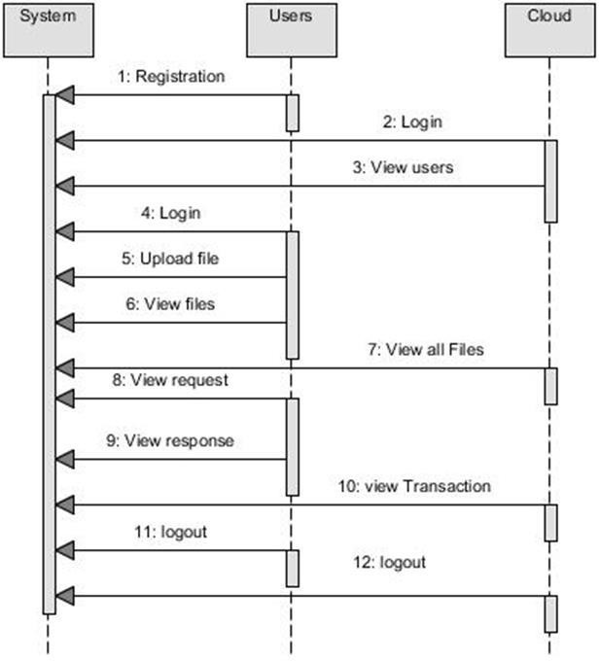
Fig.6.3.3 Sequence Diagram

ACTIVITY DIAGRAM:
Activity diagrams are graphical representations of workflows of stepwise activities and actions with support for choice, iteration and concurrency. In the Unified Modelling Language, activity diagrams can be used to describe the business and operational step-by- step workflows of components in a system. An activity diagram shows the overall flow of control.
Activity diagrams are mainly used as a flow chart consists of activities performed by the system. But activity diagram are not exactly a flow chart as they have some additional capabilities. These additional capabilities include branching, parallel flow, swim lane etc. Before drawing an activity diagram we must have a clear understanding about the elements used in activity diagram. The main element of an activity diagram is the activity itself. An activity is a function performed by the system. After identifying the activities we need to understand how they are associated with constraints and conditions. So before drawing an activity diagram we should identify the following elements.
Activities, Association, Conditions, Constraints
The following are the basic notational elements that can be used to make up a diagram:
Initial state: An initial state represents a default vertex that is the source for a single transition to the default state of a composite state. There can be at most one initial vertex in a region. The outgoing transition from the initial vertex may have a behavior, but not a trigger or guard. It is represented by Filled circle, pointing to the initial state
Final state: A special kind of state signifying that the enclosing region is completed If the enclosing region is directly contained in a state machine and all other regions in the state machine also are completed, then it means that the entire state machine is completed. It is represented by Hollow circle containing a smaller filled circle, indicating the final state.
Rounded rectangle: It denotes a state Top of the rectangle contains a name of the state Can contain a horizontal line in the middle, below which the activities that are done in that state are indicated.
Arrow: It denotes transition. The name of the event (if any) causing this transition labels the arrow body
Steps To Construct Activity Diagram Identify the preconditions of the workflow
Collect the abstractions that are involved in the operations

Beginning at the operation's initial state, specify the activities and actions Use branching to specify conditional paths and iterations
Use forking & joining to specify parallel flows of control.
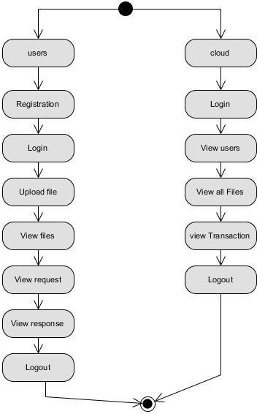

Fig.6.3.4 Activity Diagram

COLLABORATION DIAGRAM:
In collaboration diagram the method call sequence is indicated by some numbering technique as shown below. The number indicates how the methods are called one after another. We have taken the same order management system to describe the collaboration diagram. The method calls are similar to that of a sequence diagram. But the difference is that the sequence diagram does not describe the object organization whereas the collaboration diagram shows the object organization.
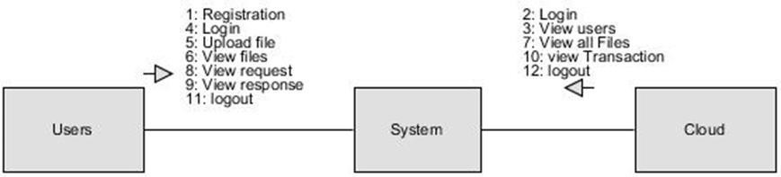
Fig.6.3.5 Collaboration Diagram

ER Diagram:
An Entity–relationship model (ER model) describes the structure of a database with the help of a diagram, which is known as Entity Relationship Diagram (ER Diagram). An ER model is a design or blueprint of a database that can later be implemented as a database. The main components of E-R model are: entity set and relationship set.
An ER diagram shows the relationship among entity sets. An entity set is a group of similar entities and these entities can have attributes. In terms of DBMS, an entity is a table or attribute of a table in database, so by showing relationship among tables and their attributes, ER diagram shows the complete logical structure of a database. Let’s have a look at a simple ER diagram to understand this concept.

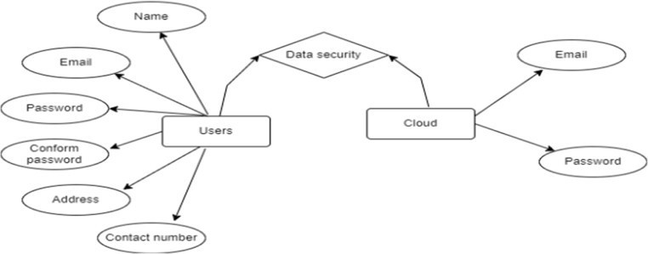

Fig.6.3.6 ER Diagram

DFD Diagram:
A Data Flow Diagram (DFD) is a traditional way to visualize the information flows within a system. A neat and clear DFD can depict a good amount of the system requirements graphically. It can be manual, automated, or a combination of both. It shows how information enters and leaves the system, what changes the information and where information is stored. The purpose of a DFD is to show the scope and boundaries of a system as a whole. It may be used as a communications tool between a systems analyst and any person who plays a part in the system that acts as the starting point for redesigning a system.
LEVEL 0:
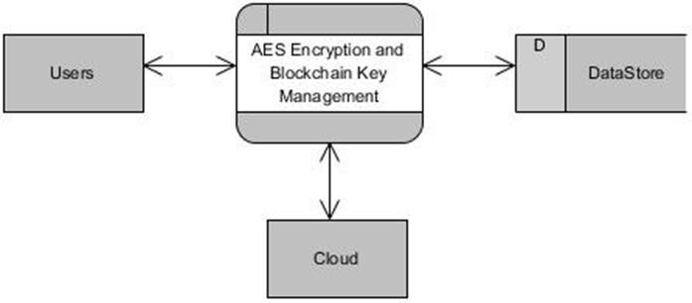
LEVEL 1 DIAGRAM:
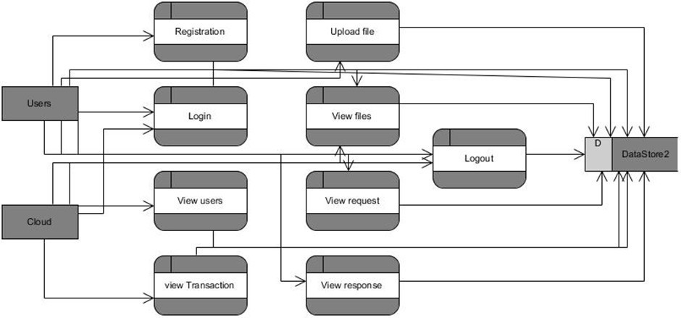

LEVEL 2 DIAGRAM:
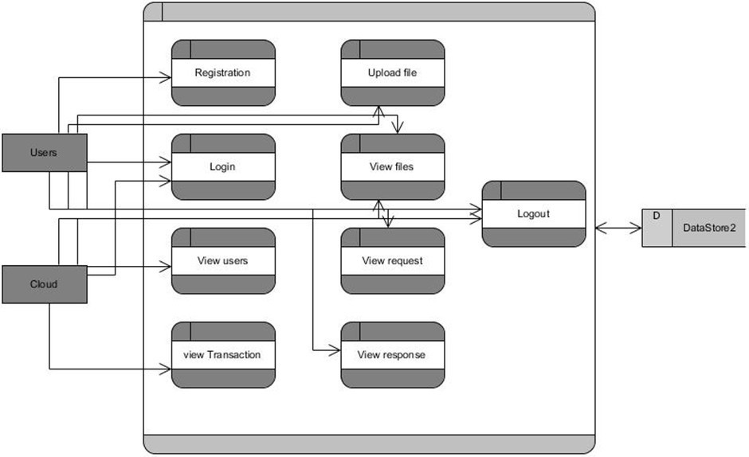

CHAPTER 7 SYSTEM IMPLEMENTATION

MODULES
- USER MODULE: This module manages user interactions, authentication, and access control.
Features:
User Registration: Users sign up by providing details like name, email, password, and contact information. Passwords are securely hashed before being stored in the database.
User Login: Users authenticate using their registered email and password. Multi-factor authentication (MFA) can be integrated for enhanced security.
Profile Management: Users can update their personal details. Password reset and recovery options are available.
Session Management: Ensures users remain authenticated while using the system.Implements session expiration and auto-logout for inactive users.
- DATA ENCRYPTION MODULE: This module is responsible for encrypting user data before storing it in the cloud.
Features:
Encrypt Data: Users enter a text message or upload a file. AES encryption is applied dynamically, generating a unique key for each file.
File Upload: The encrypted data is securely stored in the cloud. The encryption key is never stored in the cloud; instead, it is managed by the blockchain.
View Encrypted Files: Users can view a list of files they have encrypted. The system ensures that only encrypted versions of the files are visible.
- KEY MANAGEMENT WITH BLOCKCHAIN MODULE: This module is crucial for managing encryption keys securely using blockchain technology.
Features:

Generate Unique AES Keys: Every file is encrypted using a unique AES key. The system dynamically generates and assigns keys to each file.

Blockchain-Based Key Storage: Instead of storing keys in a centralized database, they are stored on a decentralized blockchain network. This ensures security, immutability, and eliminates single points of failure.
Retrieve Encryption Keys: Authorized users can request access to keys. Key retrieval is verified using blockchain authentication mechanisms.
- FILE REQUEST & DECRYPTION MODULE: This module manages requests for file access and decryption processes.
Features:

Request for Decryption Key: A user (requester) who needs access to a file submits a request to the owner. Requests are logged in the system for security auditing.
Owner Approval: The file owner receives the request and can approve or deny access. If approved, the requester receives access to the encryption key.
Decrypt Data: Using the AES key retrieved from the blockchain, the encrypted file is decrypted. Only authorized users can perform this operation.
- CLOUD STORAGE MODULE: This module handles encrypted file storage and access in the cloud.
Features:

Upload Encrypted Files: Files encrypted using AES are uploaded to a cloud storage system (e.g., AWS S3, Google Cloud, or private cloud). No plaintext (unencrypted) data is ever stored in the cloud.
View Transactions: A record of all file uploads, downloads, and key accesses is maintained. Blockchain ensures tamper-proof logging of transactions.
Security Logs: Tracks all access attempts and modifications. Helps in identifying suspicious activities and potential breaches.

SECURITY & CRYPTOGRAPHIC MODULE:
This module ensures robust encryption, secure transmission, and protection against attacks.
Features:
Advanced Encryption Standard (AES): A dynamic AES encryption mechanism is implemented to encrypt each file with a unique key. Ensures confidentiality by preventing unauthorized decryption.
Elliptic Curve Cryptography (ECC): Used for secure key exchange and transmission. Offers strong security with lower computational overhead compared to RSA.
Multi-Layer Security: Combines AES for encryption, ECC for key transmission, and blockchain for decentralized key management. Prevents MITM (Man-in-the-Middle) attacks and unauthorized access.
Access Control Policies: Ensures role-based access control (RBAC) is enforced. Only authorized users with permissions can request decryption keys.

SYSTEM ADMINISTRATION MODULE:
This module allows administrators to manage the entire system, ensuring security and compliance.
Features:
Manage Users: Admins can view, update, and deactivate user accounts. Suspicious users can be blocked from accessing the system.
Monitor File Transactions: Logs all encryption, decryption, and file-sharing activities. Ensures real-time auditing of system operations.
System Logs & Audits: Tracks failed login attempts, key access logs, and file transactions. Detects potential security threats and alerts administrators.
Backup & Recovery: Implements disaster recovery plans in case of system failures. Ensures secure backups of blockchain records and encrypted data.

SOURCE CODE:

AES CODE:
from pathlib import Path import os
# Build paths inside the project like this: BASE_DIR / 'subdir'. BASE_DIR = Path( file ).resolve().parent.parent
SECRET_KEY = 'django-insecure-syays&1e(&=- dv2*fm+1^%m$zv+spwra+c!7daq9tp&108z%$-'
DEBUG = True ALLOWED_HOSTS = [] INSTALLED_APPS = [
'django.contrib.admin', 'django.contrib.auth', 'django.contrib.contenttypes', 'django.contrib.sessions', 'django.contrib.messages', 'django.contrib.staticfiles',
'myapp'
]
MIDDLEWARE = [
'django.middleware.security.SecurityMiddleware', 'django.contrib.sessions.middleware.SessionMiddleware', 'django.middleware.common.CommonMiddleware', 'django.middleware.csrf.CsrfViewMiddleware',
'django.contrib.auth.middleware.AuthenticationMiddleware',

'django.contrib.messages.middleware.MessageMiddleware', 'django.middleware.clickjacking.XFrameOptionsMiddleware',
]
ROOT_URLCONF = 'eccaes.urls' TEMPLATES = [ {
'BACKEND': 'django.template.backends.django.DjangoTemplates', 'DIRS': [os.path.join(BASE_DIR, "templates")],
'APP_DIRS': True, 'OPTIONS': {
'context_processors': [ 'django.template.context_processors.debug', 'django.template.context_processors.request', 'django.contrib.auth.context_processors.auth',
'django.contrib.messages.context_processors.messages'
}, }, },
]
WSGI_APPLICATION = 'eccaes.wsgi.application' DATABASES = {
'default': {
'ENGINE': 'django.db.backends.sqlite3',
'NAME': BASE_DIR / 'db.sqlite3',
}}
AUTH_PASSWORD_VALIDATORS = [ {
'NAME': 'django.contrib.auth.password_validation.UserAttributeSimilarityValidator', }, {
'NAME': 'django.contrib.auth.password_validation.MinimumLengthValidator', },{ 'NAME': 'django.contrib.auth.password_validation.CommonPasswordValidator', },{

'NAME': 'django.contrib.auth.password_validation.NumericPasswordValidator',},] LANGUAGE_CODE = 'en-us'
TIME_ZONE = 'UTC'
USE_I18N = True USE_TZ = True STATIC_URL = '/static/'
STATICFILES_DIRS = [os.path.join(BASE_DIR, "static")] DEFAULT_AUTO_FIELD = 'django.db.models.BigAutoField' EMAIL_BACKEND = 'django.core.mail.backends.smtp.EmailBackend' EMAIL_HOST = 'smtp.gmail.com' # Replace with your SMTP server address EMAIL_PORT = 587 # Replace with your SMTP server port (e.g., 587 for TLS) EMAIL_USE_TLS = True # Set it to True if your SMTP server uses TLS
EMAIL_HOST_USER = 'chandu145441@gmail.com' # Replace with your email address EMAIL_HOST_PASSWORD = 'blbibwtnwqgaqhua'
ECC CODE
ECC ALOGRITHM
from cryptography.hazmat.primitives.asymmetric import ec
from cryptography.hazmat.primitives import serialization, hashes from cryptography.hazmat.primitives.kdf.hkdf import HKDF from cryptography.fernet import Fernet
import os import base64
server_private_key = ec.generate_private_key(ec.SECP384R1()) server_public_key = server_private_key.public_key() server_public_key_bytes = server_public_key.public_bytes(
encoding=serialization.Encoding.PEM,

format=serialization.PublicFormat.SubjectPublicKeyInfo
)
server_public_key = serialization.load_pem_public_key(server_public_key_bytes) client_private_key = ec.generate_private_key(ec.SECP384R1()) client_public_key = client_private_key.public_key()
client_public_key_bytes = client_public_key.public_bytes( encoding=serialization.Encoding.PEM, format=serialization.PublicFormat.SubjectPublicKeyInfo
)
client_public_key = serialization.load_pem_public_key(client_public_key_bytes) server_shared_key = server_private_key.exchange(ec.ECDH(), client_public_key) client_shared_key = client_private_key.exchange(ec.ECDH(), server_public_key) derived_key_server = HKDF(
algorithm=hashes.SHA256(), length=32,
salt=None, info=b'handshake data'
).derive(server_shared_key)
derived_key_client = HKDF( algorithm=hashes.SHA256(), length=32,
salt=None, info=b'handshake data'
).derive(client_shared_key)
assert derived_key_server == derived_key_client
fernet_key = Fernet(base64.urlsafe_b64encode(derived_key_server)) ADMIN OF ECC

from django.contrib import admin from django.urls import path
from .views import *urlpatterns = [ path('',index,name="index"), path('login/', login, name="login"), path('user/', user, name="user"),
path('viewusers/',viewusers,name="viewusers"), path('acceptuser/<int:id>', acceptuser, name='acceptuser'), path('viewcloudfiles/',viewcloudfiles,name='viewcloudfiles'), path('viewfilesrequest/',viewfilesrequest,name='viewfilesrequest'), path('encryptdata',encryptdata,name='encryptdata'), path('viewfiles',viewfiles,name='viewfiles'), path('sendrequest/<int:id>',sendrequest,name="sendrequest"), path('filerequest',filerequest,name='filerequest'), path('sendkey/<int:fileid>',sendkey,name='sendkey'), path('decryptdata',decryptdata,name='decryptdata'), path('viewmyfiles/<int:id>',viewmyfiles,name="viewmyfiles"),]
AES IMPLEMTATION
from Crypto.Cipher import AES
from Crypto.Random import get_random_bytes import base64
def pad(data):
while len(data) % 16 != 0: data += b' '
return data
def encrypt(plain_text, key):

cipher = AES.new(pad(key), AES.MODE_CBC) cipher_text = cipher.encrypt(pad(plain_text)) return base64.b64encode(cipher.iv + cipher_text)
def decrypt(encrypted_text, key):
encrypted_text = base64.b64decode(encrypted_text) iv = encrypted_text[:16]
cipher_text = encrypted_text[16:]
cipher = AES.new(pad(key), AES.MODE_CBC, iv) decrypted_text = cipher.decrypt(cipher_text)
return decrypted_text.rstrip(b' ') MODELS
from django.db import models from django.utils import timezone class userreg(models.Model):
name = models.CharField(max_length=100) email = models.CharField(max_length=50) password = models.CharField(max_length=100) contact = models.CharField(max_length=100) address = models.CharField(max_length=200)
status = models.CharField(max_length=100, default='Deactivated') class Meta:
db_table = "userreg"
class Encryptedmodel(models.Model):
useremail = models.CharField(null=True,max_length=100) textcontent = models.CharField(null=True,max_length=100) filekey = models.CharField(null=True,max_length=100)
datetime = models.DateTimeField(null=True, default=timezone.now)
encfilepath = models.CharField(null=True,max_length=100)

decfilepath = models.CharField(null=True,max_length=100) class Meta:
db_table="encryptmodel"
class Filerequestmodel(models.Model):
datetime = models.DateTimeField(null=True, default=timezone.now) status = models.CharField(default='pending',max_length=100)
class Meta:
db_table = "filerequest" VIEWS
from django.shortcuts import render,redirect
from .models import userreg,Encryptedmodel,Filerequestmodel from django.contrib import messages
from .aes import encrypt, decrypt from .ecc import *
import random
import base64
from django.conf import settings
from django.core.mail import send_mail INDEXPAGE = "index.html" loginpage = 'login.html'
regpage = 'reg.html' viewowneracpt ='viewalluser.html' cloudhomepage = 'cloudhome.html'

userhomepage = 'userhome.html' ENCRYPTDATAPAGE = "encrypt.html" VIEWFILESPAGE = "viewfiles.html" FILEREQUESTPAGE = "filerequest.html" SENDKEYPAGE = "sendkey.html" DECRYPTPAGE = "decryptpage.html" VIEWMYFILESPAGE = "viewmyfiles.html" VIEWCLOUDFILESPAGE = "cloudfile.html"
VIEWFILESREQUESTPAGE = 'filerequestcloud.html' def index(req):
return render(req,INDEXPAGE) def login(request):
if request.method == "POST":
login_type = request.POST['login_type'] email = request.POST['email'] password = request.POST['password']
if not login_type or not email or not password: messages.error(request, "All fields are required.") return render(request, loginpage)
if login_type == "cloudserver":
if email == "cloud@gmail.com" and password == "cloud": request.session['email'] = email
request.session['name'] = 'Cloud Server Admin' return render(request, cloudhomepage)
else:
messages.error(request, 'Invalid cloud server credentials.') return render(request, loginpage)
elif login_type == "user":

try:
user = userreg.objects.get(email=email, password=password, status='Activated') request.session['email'] = user.email
request.session['name'] = user.name
request.session['useremail'] = user.email # Add 'useremail' to session if password == conpasword:
data = userreg.objects.filter(
email=email, password=password).exists() if data == False:
data_insert = userreg(
name=name, email=email, password=password, contact=contact, address=address) data_insert.save()

return render(request, loginpage) else:
messages.warning(request, 'Details already exists.') return redirect("user")
usersdata = userreg.objects.filter(status='Deactivated')
return render(request, viewowneracpt, {'usersdata': usersdata}) def acceptuser(request, id):
data = userreg.objects.get(id=id) data.status = 'Activated' data.save()
# Add a success message
messages.success(request, f'The User "{data.name}" has been successfully activated.') return redirect("viewusers")
def encryptdata(req):
if req.method=="POST":
data = req.POST['message']
if req.POST['algorithm'] =="aes":
randomkey = str(random.randint(000000,999999)) secret_key =randomkey.encode()
# Original data
data = data.encode() # Encrypt data

aesencrypted_data = encrypt(data, secret_key)
path = os.path.join("static/AES/encryptedfiles/example.txt") with open(path, 'w') as file:
# Write data to the file # Write data to the file
file.write(f"{aesdecrypted_data}") encrypt_text = Encryptedmodel(
useremail = req.session['useremail'], textcontent = aesencrypted_data, filekey = secret_key,
encfilepath="static/AES/encryptedfiles/example.txt", decfilepath="static/AES/files/example.txt"
)
encrypt_text.save()
elif req.POST['algorithm'] == "ecc" :
# Encrypt a message using the Fernet cipher randomkey = str(random.randint(000000,999999)) secret_key =randomkey.encode()
message = data.encode('utf-8')
encrypted_message = fernet_key.encrypt(message)

decrypted_message = fernet_key.decrypt(encrypted_message) with open(path, 'w') as file:
file.write(f"{decrypted_message}") encrypt_text = Encryptedmodel(
useremail = req.session['useremail'], textcontent = encrypted_message, filekey = secret_key,
encfilepath="static/ECC/encryptedfiles/example.txt",
decfilepath="static/ECC/files/example.txt"
)
encrypt_text.save()
messages.success(req,"File Created Successfully") return render(req,ENCRYPTDATAPAGE)
return render(req,ENCRYPTDATAPAGE) def viewfiles(req):
# encrypted_data = Encryptedmodel.objects.filter(useremail=req.session['useremail']) # if encrypted_data:
# return render(req,VIEWFILESPAGE,{'encrypted_data':encrypted_data,'file':'yesfile'}) # else:
email = req.session['useremail']

return render(req,VIEWFILESPAGE,{'encrypted_data':encrypted_data,'file':'nofile', 'email':email})
def viewcloudfiles(req):
encrypted_data = Encryptedmodel.objects.all()
return render(req,VIEWCLOUDFILESPAGE,{'encrypted_data':encrypted_data,'file':'nofile'}) def viewfilesrequest(req):
data = Filerequestmodel.objects.all()
return render(req,VIEWFILESREQUESTPAGE,{'filedata':data}) # return
render(req,VIEWFILESREQUESTPAGE,{'encrypted_data':encrypted_data,'file':'nofile'})
def sendrequest(req,id): print(id)
data =[(j.id,j.useremail,j.textcontent,j.filekey) for j in Encryptedmodel.objects.filter(id=id)] print("=========")
print(data)
filerequest = Filerequestmodel( fileid=data[0][0],
useremail = data[0][1], textcontent = data[0][2], filekey = data[0][3],
return render(req,FILEREQUESTPAGE,{'filedata':data})

def sendkey(req,fileid): print(fileid)
dc = [(i.filekey,i.receiveremail) for i in Filerequestmodel.objects.filter(fileid=fileid,useremail=req.session['useremail'],status='pending')]
print(dc)
subject = "No reply"
cont = 'The private key to decrypt file.' key = dc[0][0]
m1 = "This message is automatic generated so dont reply to this Mail" m2 = "Thanking you"
m3 = "Regards"
m4 = "Cloud Service Provider." Email = dc[0][1]
print(key)
email_from = settings.EMAIL_HOST_USER recipient_list = [Email]
return redirect("filerequest") def decryptdata(req):
data = Filerequestmodel.objects.filter(status='approved',receiveremail=req.session['useremail']) return render(req,DECRYPTPAGE,{"filedata":data})

def viewmyfiles(req,id):
if req.method=="POST": print(" ")
filekey = req.POST['filekey']
# if filekey == aesencrypted_data.sec secret_key =filekey.encode('utf-8') try:
aesencrypted_data = [(i.decfilepath) for i in Encryptedmodel.objects.filter(id=id,filekey=secret_key)][0]
print(aesencrypted_data)
with open(aesencrypted_data,"r") as f: content = f.read()
print(content)
return render(req,VIEWMYFILESPAGE,{'id':id,'files':'False','content':content}) except:
messages.warning(req,"Key is not valid...!")
return render(req,VIEWMYFILESPAGE,{'id':id,'files':'True'} return render(req,VIEWMYFILESPAGE,{'id':id,'files':'True'})
ENCRYPTED DATA
]
operations = [

migrations.CreateModel( name='Encryptedmodel', fields=[
('id', models.BigAutoField(auto_created=True, primary_key=True, serialize=False, verbose_name='ID')),
=True)),
],
options={
'db_table': 'encryptmodel',
},
),
migrations.CreateModel( name='Filerequestmodel', fields=[
('id', models.BigAutoField(auto_created=True, primary_key=True, serialize=False, verbose_name='ID')),
('fileid', models.CharField(max_length=100, null=True)), ('useremail', models.EmailField(max_length=254, null=True)), ('textcontent', models.CharField(max_length=100, null=True)), ('receiveremail', models.CharField(max_length=100, null=True)), ('filekey', models.CharField(max_length=100, null=True)),

('datetime', models.DateTimeField(default=django.utils.timezone.now, null=True)), ('status', models.CharField(default='pending', max_length=100)),
],
options={
'db_table': 'userreg',
class Migration(migrations.Migration): initial = True

dependencies = [
]
operations = [ migrations.CreateModel(
name='Encryptedmodel', fields=[
('id', models.BigAutoField(auto_created=True, primary_key=True, serialize=False, verbose_name='ID')),
('useremail', models.CharField(max_length=100, null=True)), ('textcontent', models.CharField(max_length=100, null=True)), ('filekey', models.CharField(max_length=100, null=True)),
('datetime', models.DateTimeField(default=django.utils.timezone.now, null=True)), ('encfilepath', models.CharField(max_length=100, null=True)),
('decfilepath', models.CharField(max_length=100, null=True)), ], options={
'db_table': 'encryptmodel',
}, ),
migrations.CreateModel( name='Filerequestmodel', fields=[
('id', models.BigAutoField(auto_created=True, primary_key=True, serialize=False, verbose_name='ID')),
('fileid', models.CharField(max_length=100, null=True)), ('useremail', models.EmailField(max_length=254, null=True)), ('textcontent', models.CharField(max_length=100, null=True)), ('receiveremail', models.CharField(max_length=100, null=True)),

('filekey', models.CharField(max_length=100, null=True)),
('datetime', models.DateTimeField(default=django.utils.timezone.now, null=True)),
('status', models.CharField(default='pending', max_length=100)),
],
options={
'db_table': 'filerequest',
}, ),
migrations.CreateModel( name='userreg', fields=[
options={
'db_table': 'userreg',
}, ), ] CLOUD FILES
<div class="container">
<center><h2 style="color:rgb(48, 241, 241);">View my Files</h2></center>
<div class="card shadow-lg mb-8">
<div class="card-body">

<div class="table-responsive" style="max-height: 30rem; overflow-y: auto;">
<table class="table table-dark table-hover" style="color: white;">
<thead>
<tr>
{% for data in encrypted_data %}
<tr>
<td>{{ data.id }}</td>
<td>{{ data.useremail }}</td>
<td>{{ data.textcontent }}</td>
<td>{{ data.datetime }}</td>
</tr>
{% endfor %}
{% else %}
{% for data in encrypted_data %}
<tr>
<td>{{ data.id }}</td>
<td>{{ data.useremail }}</td>
<td>{{ data.textcontent }}</td>

<td>{{ data.datetime }}</td>
</tr>
{% endfor %}
{% endif %}
</tbody>
</table>
</div></div></div></div>
<script>
// Optional JavaScript for additional features can be added here
// For example, tooltips for action buttons document.addEventListener('DOMContentLoaded', function () {
var tooltipTriggerList = [].slice.call(document.querySelectorAll('[data-bs-toggle="tooltip"]')) var tooltipList = tooltipTriggerList.map(function (tooltipTriggerEl) {
return new bootstrap.Tooltip(tooltipTriggerEl)
})
});

<thead class="thead-light">
<tr>
<th scope="col">#</th>
<th scope="col">Receiver Email</th>
<th scope="col">Text Content</th>
<th scope="col">Date Time</th>
<th scope="col">Action</th>
</tr>
</thead>
<tbody>
{% for data in filedata %}
<tr>

<td>{{ data.id }}</td>

<td>{{ data.receiveremail }}</td>

<td>{{ data.textcontent }}</td>

<td>{{ data.datetime }}</td>

<td>

<a href="{% url 'viewmyfiles' data.fileid %}" class="btn btn-primary" data-bs- toggle="tooltip" data-bs-placement="top" title="View file content">View File</a>
</td></tr>

{% endfor %}

</tbody></table>

</div></div></div></div>

<script>

// Activate tooltips document.addEventListener('DOMContentLoaded', function () {
var tooltipTriggerList = [].slice.call(document.querySelectorAll('[data-bs-toggle="tooltip"]')) var tooltipList = tooltipTriggerList.map(function (tooltipTriggerEl) {
return new bootstrap.Tooltip(tooltipTriggerEl)})
});
</script>

CHAPTER 8 TESTING

TESTING STRATEGIES
Testing strategies refer to the systematic approaches and methodologies used to verify the functionality, performance, security, and reliability of a software system. They define the scope, objectives, techniques, and sequence of testing activities to ensure the software meets its requirements and performs as expected.
The purpose of testing is to discover errors. Testing is the process of trying to discover every conceivable fault or weakness in a work product. It provides a way to check the functionality of components, sub-assemblies, assemblies and/or a finished product It is the process of exercising software with the intent of ensuring that the
Software system meets its requirements and user expectations and does not fail in an unacceptable manner. There are various types of test. Each test type addresses a specific testing requirement.

TYPES OF TESTING
    - UNIT TESTING
Unit testing involves the design of test cases that validate that the internal program logic is functioning properly, and that program inputs produce valid outputs. All decision branches and internal code flow should be validated. It is the testing of individual software units of the application .it is done after the completion of an individual unit before integration. This is a structural testing, that relies on knowledge of its construction and is invasive. Unit tests perform basic tests at component level and test a specific business process, application, and/or system configuration. Unit tests ensure that each unique path of a business process performs accurately to the documented specifications and contains clearly defined inputs and expected results.

INTEGRATION TESTING
Integration tests are designed to test integrated software components to determine if they actually run as one program. Testing is event driven and is more concerned with the basic outcome of screens or fields. Integration tests demonstrate that although the components were individually satisfaction, as shown by successfully unit testing, the

combination of components is correct and consistent. Integration testing is specifically aimed at exposing the problems that arise from the combination of components.
Software integration testing is the incremental integration testing of two or more integrated software components on a single platform to produce failures caused by interface defects. The task of the integration test is to check that components or software applications, e.g. components in a software system or – one step up – software applications at the company level – interact without error.
Test Results: All the test cases mentioned above passed successfully. No defects encountered.

ACCEPTANCE TESTING
User Acceptance Testing is a critical phase of any project and requires significant participation by the end user. It also ensures that the system meets the functional requirements.
Test Results: All the test cases mentioned above passed successfully. No defects encountered.

FUNCTIONAL TESTING
Functional tests provide systematic demonstrations that functions tested are available as specified by the business and technical requirements, system documentation, and user manuals.
Functional testing is centered on the following items:
Valid Input : identified classes of valid input must be accepted. Invalid Input : identified classes of invalid input must be rejected. Functions : identified functions must be exercised.
Output : identified classes of application outputs must be exercised.

Systems/Procedures: interfacing systems or procedures must be invoked.
Organization and preparation of functional tests is focused on requirements, key functions, or special test cases. In addition, systematic coverage pertaining to identify Business process flows; data fields, predefined processes, and successive processes must

be considered for testing. Before functional testing is complete, additional tests are identified and the effective value of current tests is determined.

SYSTEM TESTING
System Testing ensures that the entire integrated software system meets requirements It tests a configuration to ensure known and predictable results. A n example of system testing is the configuration oriented system integration test.System testing is based on process descriptions and flows, emphasizing pre-driven process links and integration points.

WHITE BOX TESTING
White Box Testing is a testing in which in which the software tester has knowledge of the inner workings, structure and language of the software, or at least its purpose. It is used to test areas that cannot be reached from a black box level.

BLACK BOX TESTING
Black Box Testing is testing the software without any knowledge of the inner workings, structure or language of the module being tested. Black box tests, as most other kinds of tests, must be written from a definitive source document, such as specification or requirements document, such as specification or requirements document. It is a testing in which the software under test is treated, as a black box. you cannot “see” into it. The test provides inputs and responds to outputs without considering how the software works.
Test objectives
- All field entries must work properly.
- Pages must be activated from the identified link.
- The entry screen, messages and responses must not be delayed.

Features to be tested
  - Verify that the entries are of the correct format
  - No duplicate entries should be allowed
  - All links should take the user to the correct page

TEST CASES:
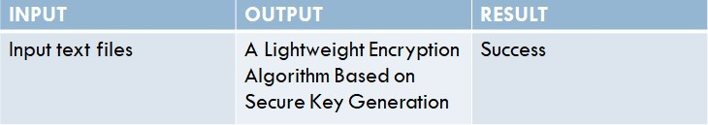

Table 8.3: Test cases

TEST CASES MODEL BUILDING:
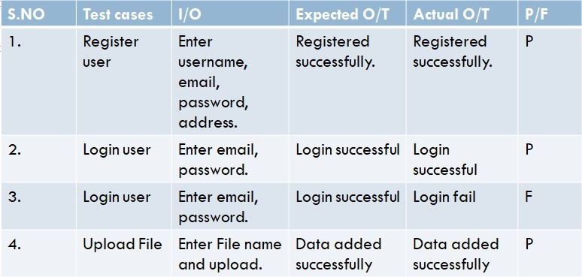

Table 8.4: Test cases model building

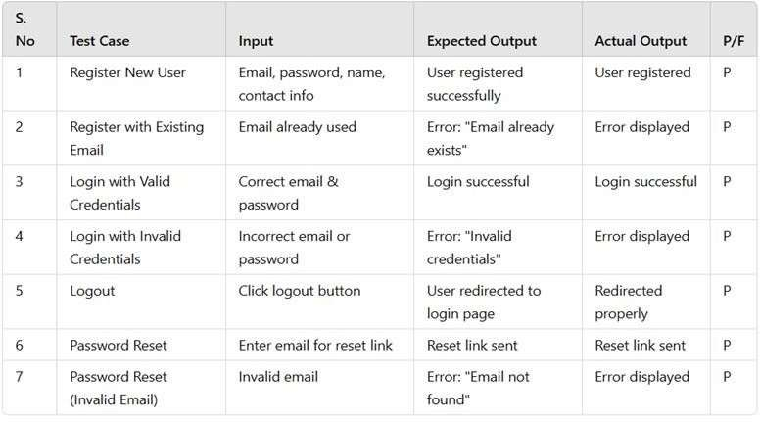

Table 8.4.1: Test cases
- A Light Weight Text Message Is Generated As The Final Output And It Is Securly Transmitted To The Desired Location. By Integrating Dynamic Aes, Block Chain Key Management And Ecc Cloud Providers And Users Gain Stronger, More Efficient Data Protection, Improved Operational Speed, And Reduced Costs, Addressing Modern Cloud Security Challenges And Establishing A New Standard For Secure Data Encryption, Making It A Valuable Asset In Ensuring Data Security In Modern Cloud Infrastructures.

CHAPTER 9 SCREEN LAYOUT
- Navigate to the File Name :- eccaes

- The prescribed IP Address for the following procedures will be Displayed.



- Home page: A Dynamic AES Encryption and Blockchain Key Management: A Novel Solution for Cloud Data Security home page.

- Registration: The Data owner will register with the details like name, email, password, contact, address they will register.

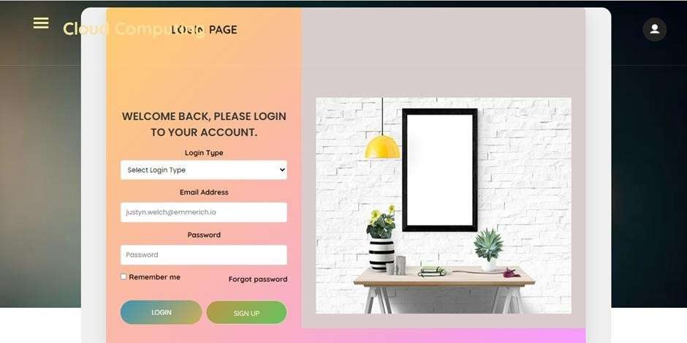
- Login: After registration the owner will login with email and password.


- Data Owner home page

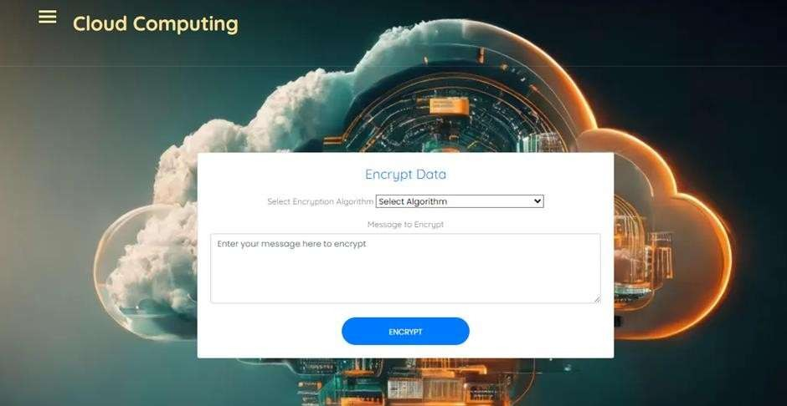
- Encrypt Data: Here the user will enter text message and it will content into the encrypted file.

- User can View all the files.

- User send request: The user can see all file and send request for the file.

- View Response: If the owner accept the user can view here.

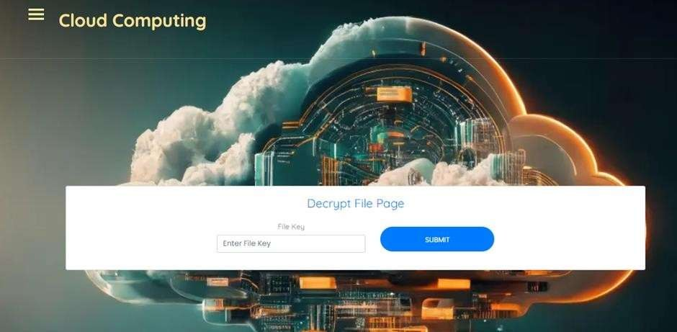
- Enter Key: Here enter the key.

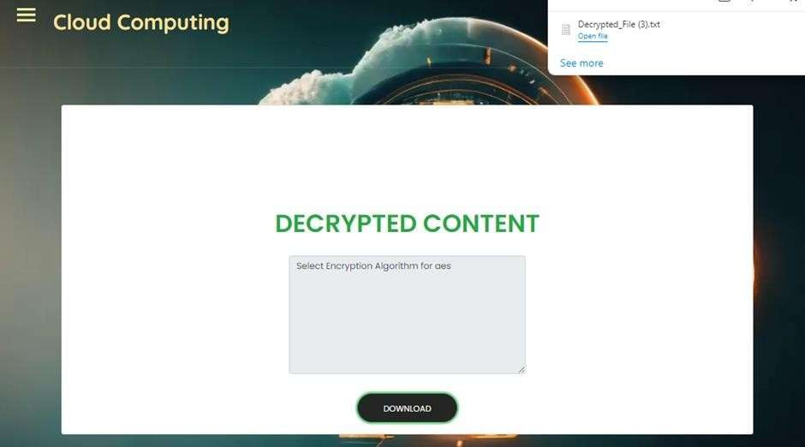
- View Result: View result and download.

CHAPTER 10 APPLICATIONS AND ADVANTAGES

APPLICATIONS OF THE PROJECT:

Secure Cloud Storage
      - Protects sensitive data stored in cloud platforms by using dynamic AES encryption with unique keys for each file.
      - Reduces risks of mass data breaches even if a single key is compromised.

Enterprise Data Management
      - Suitable for organizations needing decentralized, tamper-proof key management (e.g., legal firms, banks, IT companies).
      - Ensures secure file sharing across departments or between partners using ECC.

Healthcare Systems
      - Ideal for securing Electronic Medical Records (EMRs) where privacy, integrity, and authorized access are critical.
      - Blockchain ensures traceability and integrity of encryption keys.

Financial Sector
      - Protects confidential financial records and transactions stored or shared over cloud systems.
      - Prevents unauthorized access via robust, decentralized key control.

Government and Military
      - Enhances classified data protection with layered encryption and immutable key management.
      - ECC provides secure communication between distributed systems.

IoT and Edge Devices
      - The lightweight nature of ECC makes the system applicable in resource- constrained environments (smart homes, industrial IoT).

ADVANTAGES OF THE PROJECT:

Dynamic AES Encryption
  - Every file gets a unique key, ensuring that the compromise of one key doesn’t affect other files.
  - Limits the impact of potential breaches.

Decentralized Key Management using Blockchain
  - Removes the single point of failure by distributing key management.
  - Enhances transparency and immutability in key access and tracking.

Improved Transmission Security
  - Integration with ECC ensures that encryption keys and data can be securely shared over untrusted networks.

Scalability and Adaptability

  - System is designed to handle growth in data and users without degradation in security performance.
  - Easily adaptable to different domains with varied security requirements.

Enhanced User Trust
  - Blockchain fosters trust with its transparency and accountability.
  - Helps users and clients feel more confident storing data on the cloud.

Efficient Performance
  - ECC provides strong security with smaller key sizes, resulting in faster performance and lower resource usage than RSA.

CHAPTER 11 CONCLUSION AND FUTUE SCPOE

CONCLUSION:
The hybrid system for cloud data security effectively addresses the critical vulnerabilities inherent in traditional encryption methods. By integrating dynamic AES encryption with blockchain technology, the system significantly enhances data protection through unique, constantly changing encryption keys and decentralized key management. This innovative approach not only fortifies security against unauthorized access and data breaches but also improves user trust through transparency and accountability. With its scalable and adaptable architecture, the system is well-suited to meet the evolving security demands of cloud environments, ensuring the confidentiality, integrity, and availability of sensitive data. Overall, this solution represents a substantial advancement in safeguarding cloud data security.

FUTURE SCOPE:
Future enhancements to the proposed cloud data security system could focus on several key areas. First, incorporating artificial intelligence (AI) and machine learning algorithms can improve threat detection and response times, enabling the system to proactively identify and mitigate potential security breaches. Additionally, implementing multi-factor authentication (MFA) and biometric verification can further strengthen user access controls, ensuring that only authorized individuals can access sensitive data. Moreover, the integration of secure homomorphic encryption would allow data to be processed in an encrypted state, enhancing privacy while enabling useful computations without exposing the data itself. Further exploration of interoperability with other blockchain platforms can facilitate seamless data sharing across different cloud environments while maintaining security. Finally, continuous updates and assessments of encryption algorithms will ensure resilience against emerging cryptographic attacks, adapting to the rapidly evolving landscape of cybersecurity threats and maintaining robust data protection for users.

CHAPTER 12 BIBLIOGRAPHY

REFERENCES:
    - S. Rehman, N. Talat Bajwa, M. A. Shah, A. O. Aseeri, and A. Anjum,‘‘Hybrid AES-ECC model for the security of data over cloud storage,’’Electronics, vol. 10, no. 21, p. 2673, Oct. 2021
    - S. K. Dwivedi, R. Amin, J. D. Lazarus, and V. Pandi, ‘‘Blockchain based electronic medical records system with smart contract and consensus algorithm in cloud environment,’’ Secur. Commun. Netw., vol. 2022, pp. 1–10, Sep. 2022.
    - G. Habib, S. Sharma, S. Ibrahim, I. Ahmad, S. Qureshi, and M. Ishfaq, ‘‘Blockchain technology: Benefits, challenges, applications, and integration of blockchain technology with cloud computing,’’ Future Internet, vol. 14, no. 11, p. 341, Nov. 2022.
    - K. Bhalla, D. Koundal, S. Bhatia, M. Khalid Imam Rahmani, and M. Tahir, ‘‘Dynamic encryption and secure transmission of terminal data files,’’ Comput., Mater. Continua, vol. 71, no. 1, pp. 1221–1232, 2022
    - I. Keshta, Y. Aoudni, M. Sandhu, A. Singh, P. A. Xalikovich, A. Rizwan, M. Soni, and S. Lalar, ‘‘Blockchain aware proxy re-encryption algorithm based data sharing scheme,’’ Phys. Commun., vol. 58, Jun. 2023, [6] F. Thabit, O. Can, S. Alhomdy, G. H. Al-Gaphari, and S. Jagtap, ‘‘A novel effective lightweight homomorphic cryptographic algorithm for data security in cloud computing,’’ Int.
J. Intell. Netw., vol. 3, pp. 16–30, 2022.
    - D. C. Nguyen, P. N. Pathirana, M. Ding, and A. Seneviratne, ‘‘Integration of blockchain and cloud of things: Architecture, applications and challenges,’’ IEEE Commun. Surveys Tuts., vol. 22, no. 4, pp. 2521–2549, 4th Quart., 2020.
    - S. N. G. Gourisetti, Ü. Cali, K.-K.-R. Choo, E. Escobar, C. Gorog, A. Lee, C. Lima, M. Mylrea, M. Pasetti, F. Rahimi, R. Reddi, and A. S. Sani, ‘‘Standardization of the distributed ledger technology cybersecurity stack for

power and energy applications,’’ Sustain. Energy, Grids Netw., vol. 28, Dec. 2021, Art. no. 100553.
    - S. Banani, S. Thiemjarus, K. Wongthavarawat, and N. Ounanong, ‘‘A dynamic light-weight symmetric encryption algorithm for secure data transmission via BLE beacons,’’ J. Sensor Actuator Netw., vol. 11, no. 1, p. 2, Dec. 2021.
    - I. Keshta, Y. Aoudni, M. Sandhu, A. Singh, P. A. Xalikovich, A. Rizwan, M. Soni, and S. Lalar, ‘‘Blockchain aware proxy re-encryption algorithm based data sharing scheme,’’ Phys. Commun., vol. 58, Jun. 2023, Art. no. 102048.
    - O. A. Khashan, N. M. Khafajah, W. Alomoush, M. Alshinwan, S. Alamri, S. Atawneh, and M. K. Alsmadi, ‘‘Dynamic multimedia encryption using a parallel file system based on multi-core processors,’’ Cryptography, vol. 7, no. 1, p. 12, Mar. 2023.
    - R. Anandkumar, K. Dinesh, A. J. Obaid, P. Malik, R. Sharma, A. Dumka, R. Singh, and S. Khatak, ‘‘Securing e-health application of cloud computing using hyperchaotic image encryption framework,’’ Comput. Electr. Eng., vol. 100, May 2022, Art. no. 107860.

    - X. Liu, R. Zhang, and M. Zhao, ‘‘A robust authentication scheme with dynamic password for wireless body area networks,’’ Comput. Netw., vol. 161, pp. 220– 234, Oct. 2019.
    - M. Yousefpoor and H. Barati, ‘‘Dynamic key management algorithms in wireless sensor networks: A survey,’’ Comput. Commun., vol. 134, pp. 52–69, Jan. 2019.
    - R. K. Chaurasiya, B. Acharya, and P. Singh, ‘‘A comparative survey on lightweight block ciphers for resource constrained applications,’’ Int. J. High Perform. Syst. Archit., vol. 8, no. 4, p. 250, 2019.

